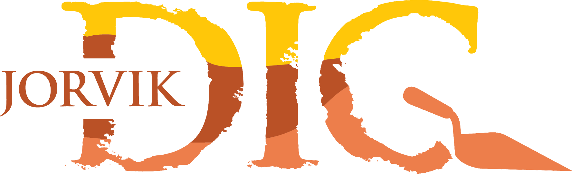

Accessibility Guide for DIG:
An Archaeological Adventure
DIG@yorkat.co.uk, 01904 615505, http://digyork.com/
Contact for accessibility enquiries: access@yorkat.co.uk

Welcome
DIG is a hands-on archaeological adventure giving kids the chance to become trainee archaeologists and discover the most exciting artefacts from 2000 years of York’s history! With four special in-door excavation pits, all based on real-life archaeological digs in the city. Filled with replica Roman, Viking, Medieval and Victorian finds, children can grab a trowel and explore how people lived in these times. DIG is a very adaptable, tactile learning environment and warmly welcomes all disabled visitors. Tours run every half an hour and last for about an hour.
For any adults wanting to visit DIG, we offer DIG Deeper - a tour created especially for adults offering an in-depth look at the archaeological process. Please book on the last tour of the day.

At a Glance
There is level access to the entrance and throughout the building. There is a lift to the first floor and an accessible toilet. All staff have disability awareness and Autism Awareness training whilst some staff have BSL training.
Glass doors have contrast markings. We have interpretation available in level 1 Braille translation and in large print. Visual stories are available to download on our website and we have paper copies at our front desk.
We have a complimentary ticket policy for carers and personal assistants, and all tickets are valid for one year, allowing as many returns and re-entries as you like. Seating is available throughout the building, and we have sensory packs for you to use at our front desk.
Sensory information: due to the nature of the building, DIG can get very loud. We are in a converted medieval church with lots of open space and hard surfaces so noise travels and echoes a lot, especially if we have multiple school groups. We do have a small number of ear defenders available and subject to availability, we also have a quiet space if you get overwhelmed. Our garden is always available for you to take a breather too. During term time, afternoons after 3pm tend to be quieter as well as most weekends, especially in the morning. Outside of term time, Sunday mornings tend to be our quietest time. If you want to schedule a visit for a quieter time, contact our reservations team at groups@yorkat.co.uk and they’ll be able to find a time that suits you.

Getting here
St Saviour's Church
St Saviourgate
York
YO1 8NN
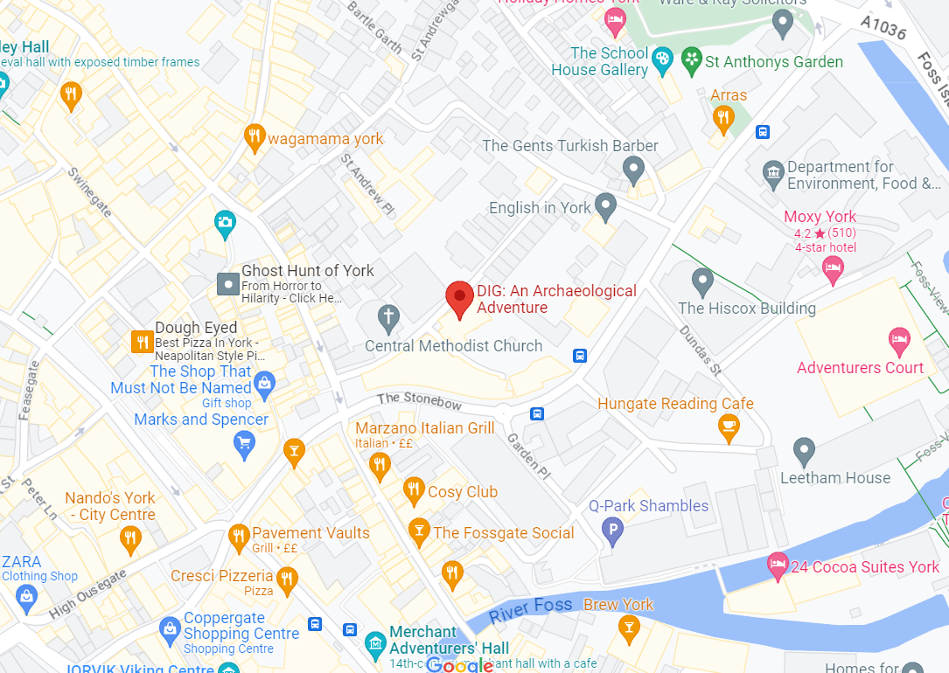
https://goo.gl/maps/bBJVVDFjgTBCjH9t6
what3words: stay.focal.tame

Travel by public transport
You can get to DIG: An Archaeological Adventure by bus and train.

Bus
The nearest bus stop is a string of stops around the corner along Stonebow. York First buses, Coastliner, and CityZap all have stops along there. The bus stop is 0.1 miles / 0.2 km from DIG: An Archaeological Adventure.

Train
The nearest train station is York Rail Station. The train station is 0.8 miles / 1.3 km from DIG: An Archaeological Adventure. York is on the East Coast main line between London and Scotland. It takes less than two hours to get to York from London. Trains run every half an hour, with at least 25 direct trains each week day.
Direct rail services also run to York from many of the UK's main regional centres. York can be reached easily from all the following centres: Edinburgh, Glasgow, Birmingham, Bristol, Leeds, Manchester, Newcastle, Nottingham, and Liverpool. There are direct trains to and from Manchester International Airport that run every hour during the day.

Travel by taxi
The nearest drop off point for taxis is the taxi rank along St Saviourgate - right outside the attraction. There is level access from the pavement and a slight ramp from street level.
You can get a taxi with Streamline by calling 01904 656565. The taxi company has a wheelchair accessible vehicle.

Parking
There is no on-site parking at DIG. The nearest car park is the Foss Bank car park, just a 7-minute walk (0.3 mi) away. The car park has 4 dedicated disabled parking bays.
You can find out more information about it here: https://www.york.gov.uk/directory-record/405/foss-bank-car-park-yo31-7pl

Arriving at DIG
There is level access from the street to the main entrance with a dropped curb right outside our door.
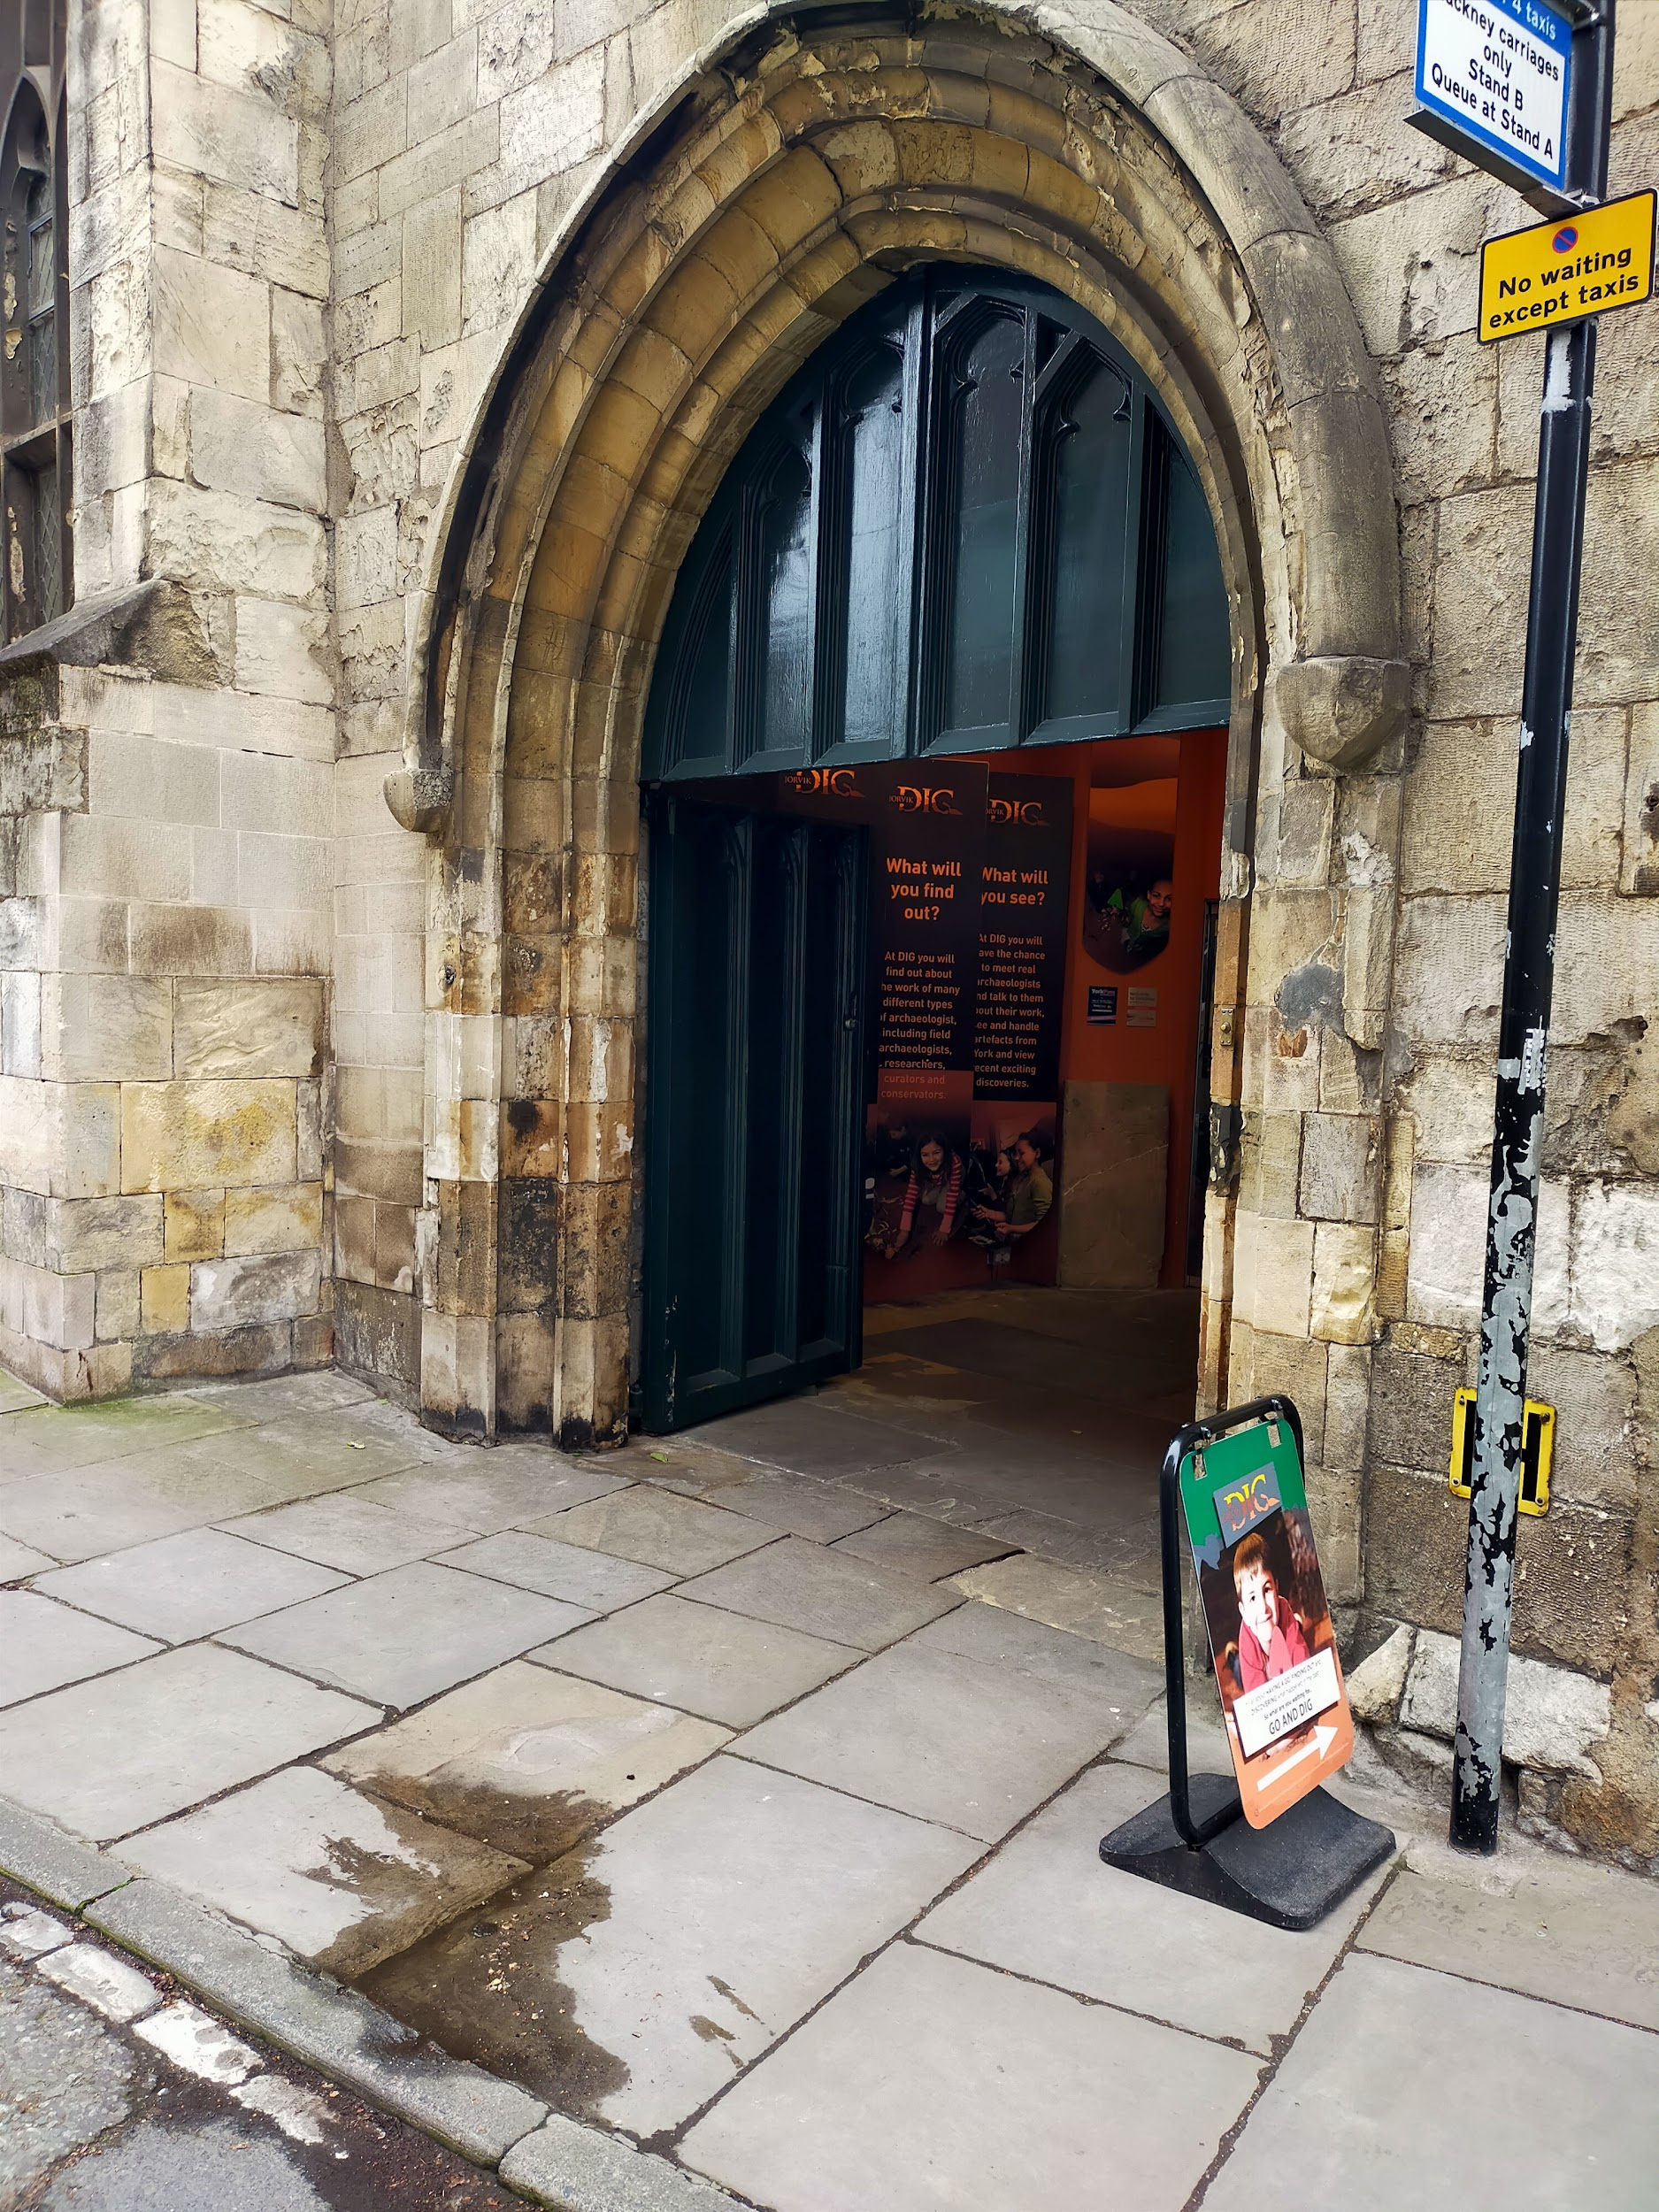
The main entrance has level access and two sets of double doors. The outer set is always open - although during colder weather, we close one door, but the doorway is still over 1m wide. The doors swing inwards.
The second set of doors are glass with contrast markings on them. They are a combined 2140mm wide and weather permitting, they are kept open during operating hours. They swing both inwards and outwards and are manual - however, immediately inside the doors is a permanently staffed admissions desk and the staff member there will happily help you with the door.

Inside DIG
DIG is housed inside a converted medieval church. Because it’s a listed building, there’s lots of things we can’t alter. However, we’ve done what we can and we’re always happy to hear feedback on ways we can improve.

Lift
We have one lift to go between the two floors of our building. It’s a platform lift with a door that is 900mm wide and swings outward. There is a ramp on the ground level to get into the lift and there is level access on the first floor.
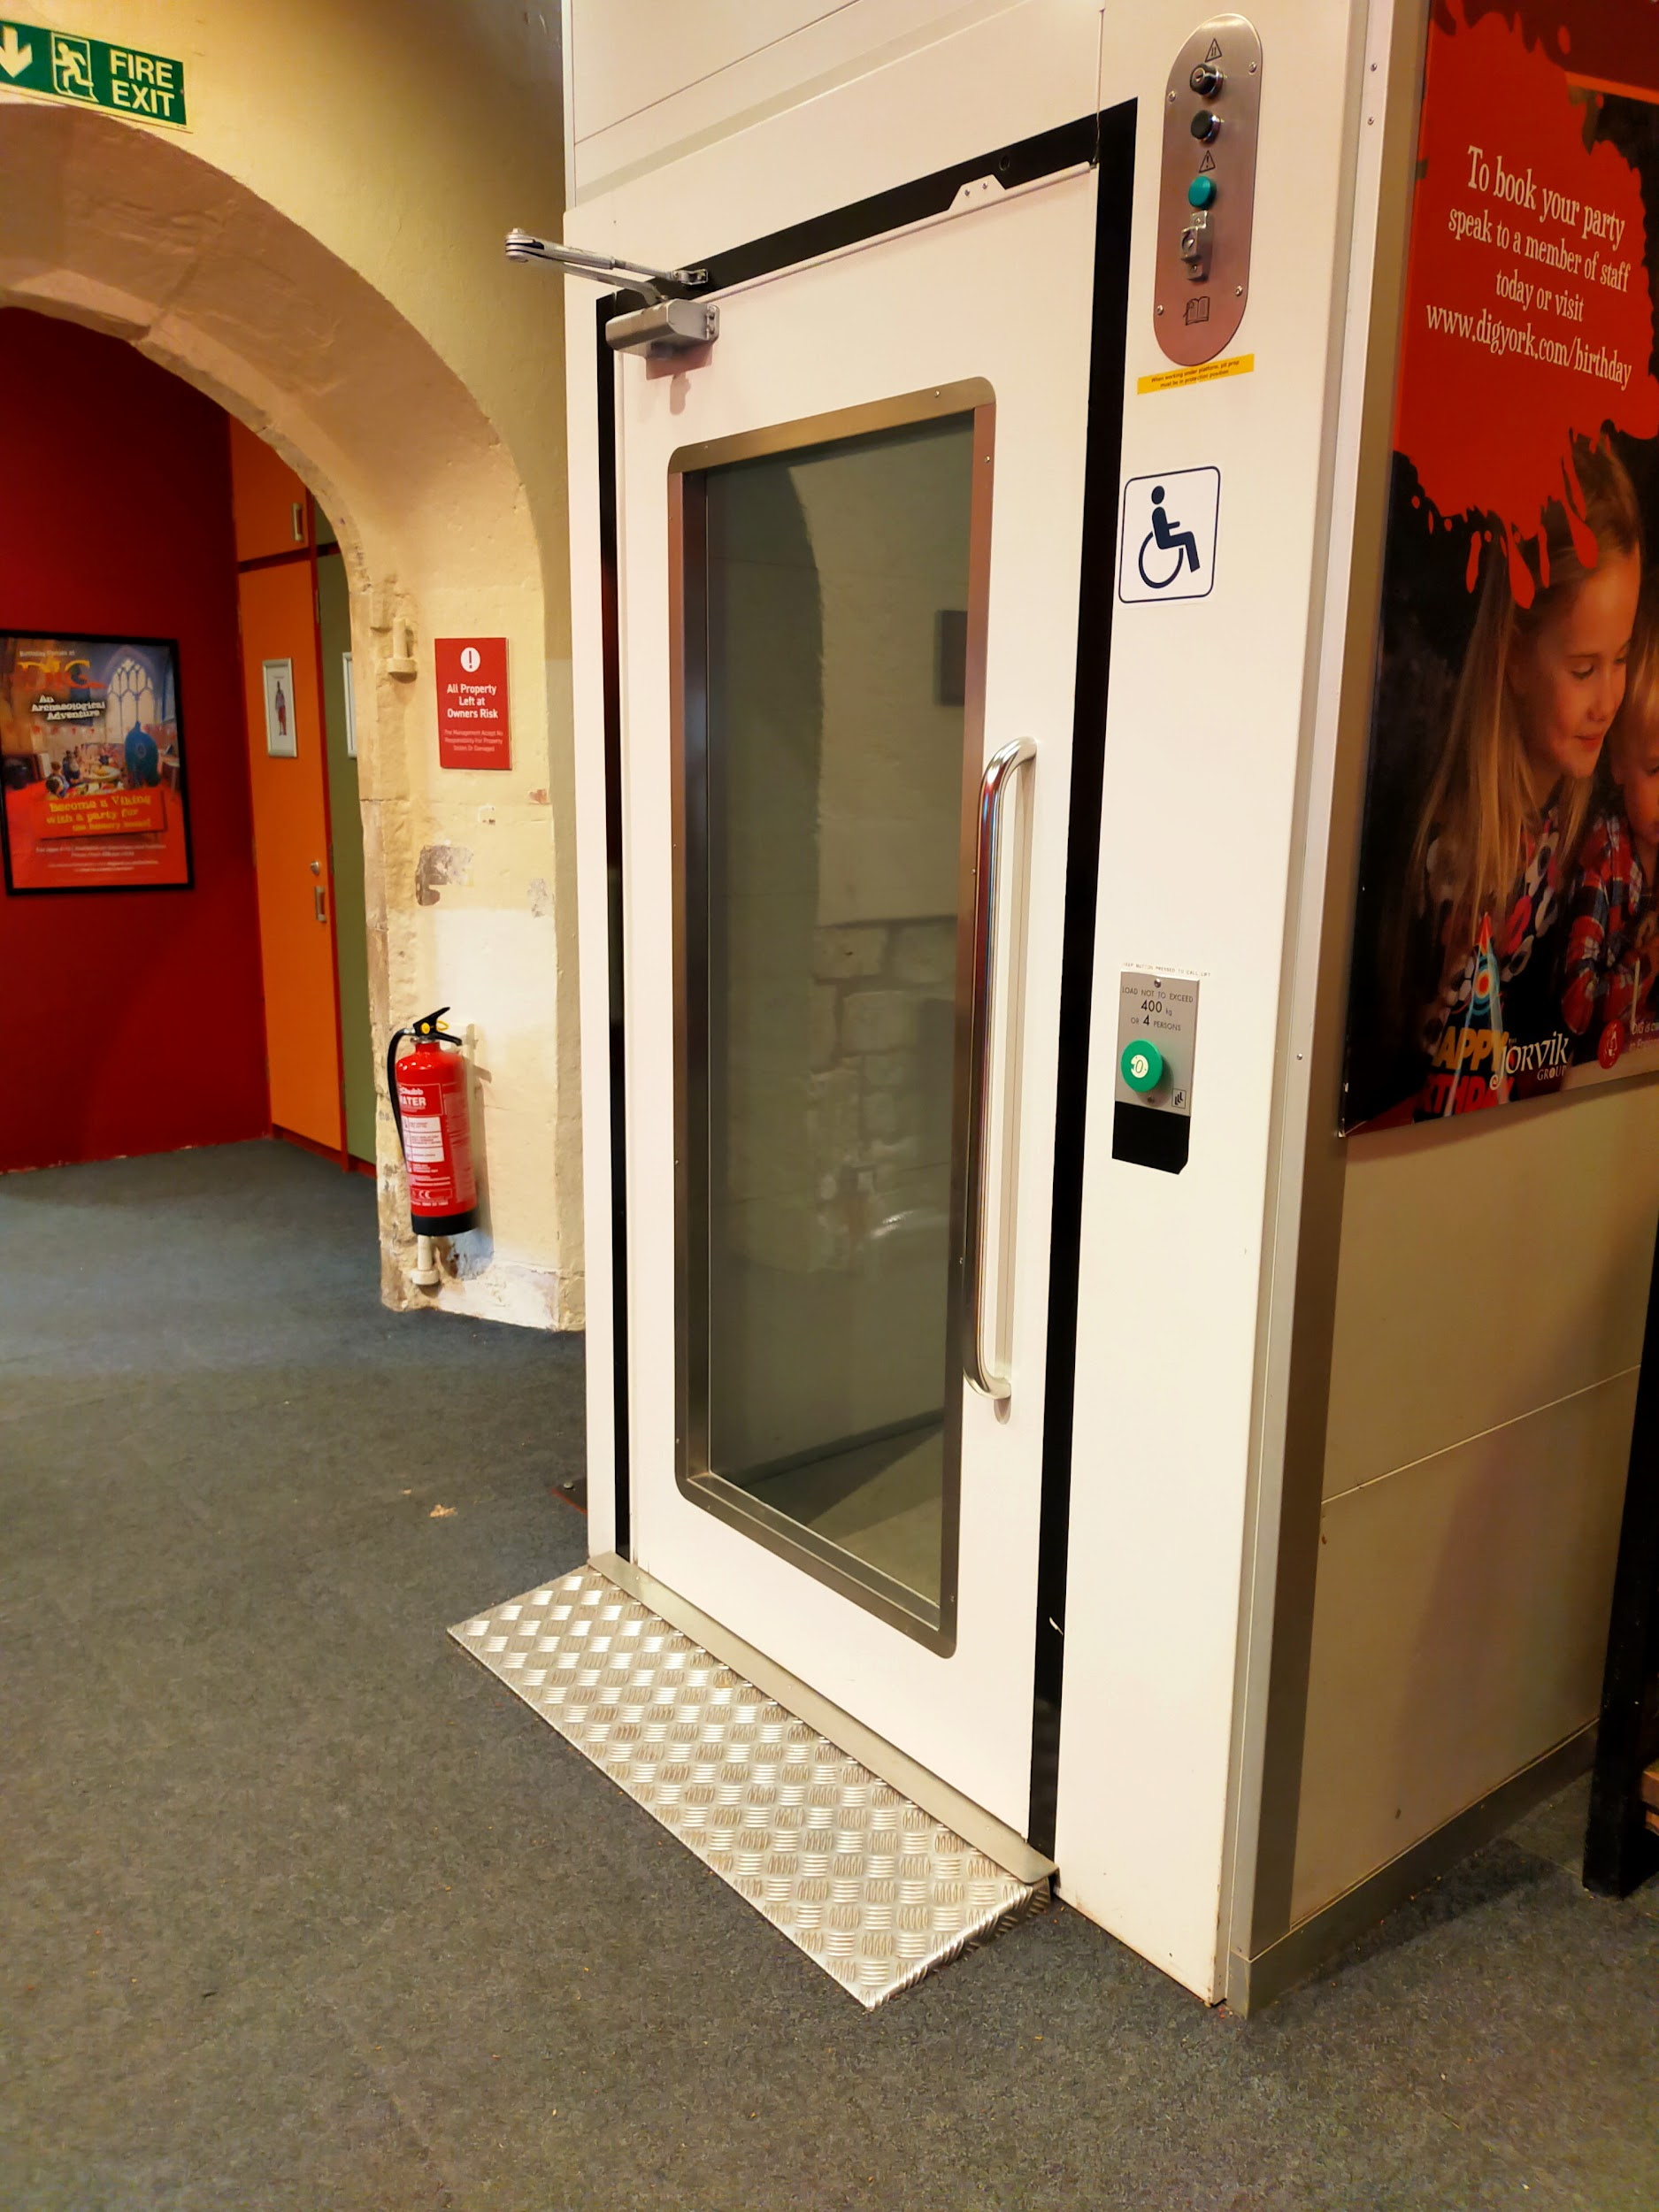
The inside of the lift is 1100mm wide and 1370mm long - these are working measurements, so they cannot be exceeded. The lift can only carry two adults or an adult with a pushchair at a time. The maximum load for the lift is 400kg.
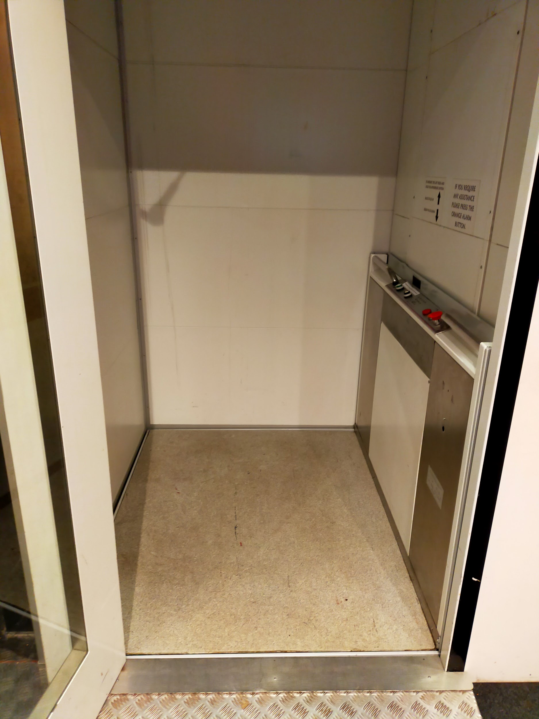
In order to call the lift, you need to hold down the button on the outside right hand side. To move the lift, you need to hold down the button for the floor you want. The controls are 870mm off the ground.
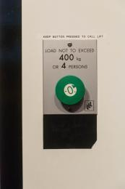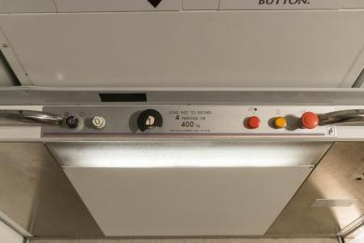
The lift is quite old and makes noise as it moves - we have it serviced regularly and promise this is fine! Professional technicians have checked and it’s just the noise of an old lift.
Sometimes the lift is out of service, but when this happens, we will post it on our social media channels and work to get it back in operation as soon as possible.

Ground Floor
The ground level of DIG is a large, mostly open area with stone walls and pillars and several different types of flooring. There is level access through the ground floor and a lift to take you to the first floor. There are hooks to hang coats and sometimes lockers are available for bags - these are mostly used by schools, so they are subject to availability.
The ground floor consists of the following areas:
- Front desk/admissions area
- Shop
- Discover Archaeology - Pod Area
- Do Archaeology - Dig Sites
- Little Diggers - Unders 5s Area
- Nave exhibition
- Exhibition Galleries
- Community Gallery
- Toilets
  - Accessible Toilet
  - Public Toilet - Women
  - Public Toilet - Men

Front Desk
The desk is our admissions area as well as the till for our shop. When you enter, the staff member on the desk will ask for the name of your booking and reference number if you have pre-booked. If you have any discounts, such as a Max card, you may be asked to show proof of eligibility. This simply means showing your Max card, NHS staff card, or similar card.
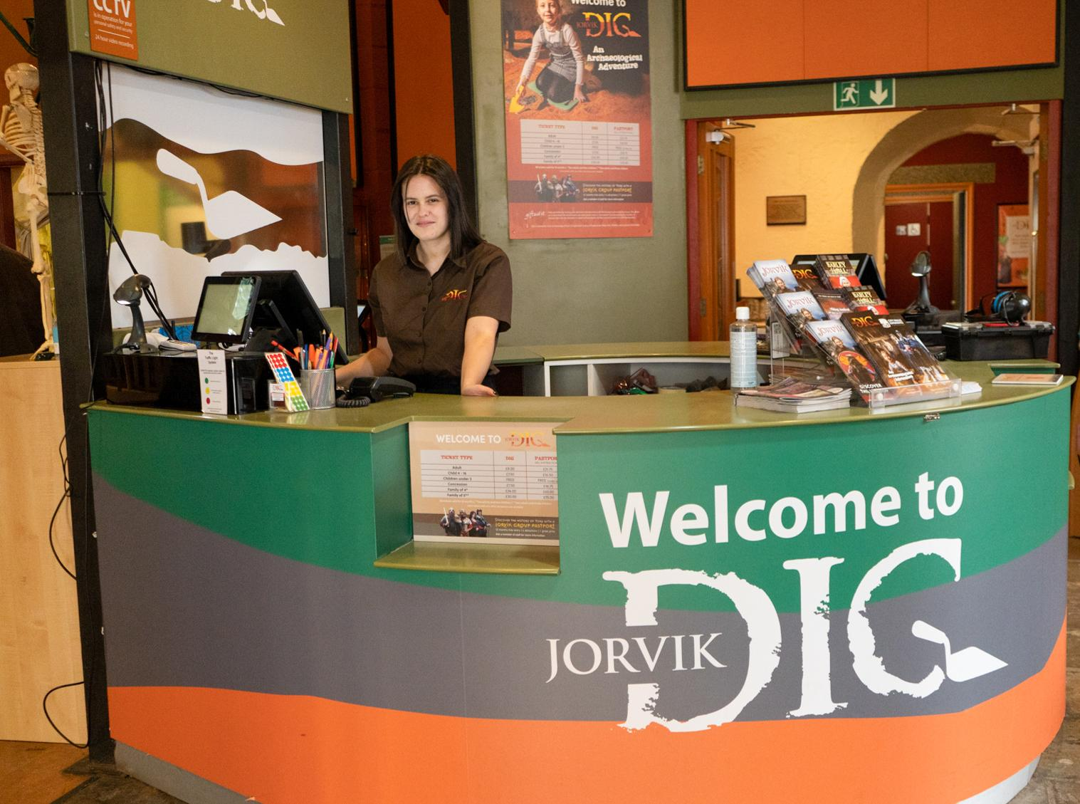
The desk is located just inside the front doors and is always staffed by at least one staff member. There is level access from the front door and the narrowest section is 860mm. The desk has two low sections, one at each till. The high section of the desk is 1000mm high, whilst the low section is 710mm high.
The area has a flagstone floor, so it is not perfectly smooth but it is level. Generally, there is not a queue for DIG, but in the event of a queue, we operate a ‘queue jump’ system - just make yourself known to the staff member at the front desk and they will serve you as soon as possible.
There is full wheelchair access throughout DIG, but due to number restrictions and space limitations on tours, we may have to limit the number of wheelchair users per tour slot (they run every 30 minutes).
We offer complimentary tickets for carers and personal assistants, no proof required. Service animals are welcome and we have a water bowl at the front desk available for us.
We keep a number of access items at the front desk, including braille interpretation for our galleries, large print guides, sensory bags, ear defenders, and physical copies of our access guides and visual stories. You can also ask to use our complimentary wheelchair here.
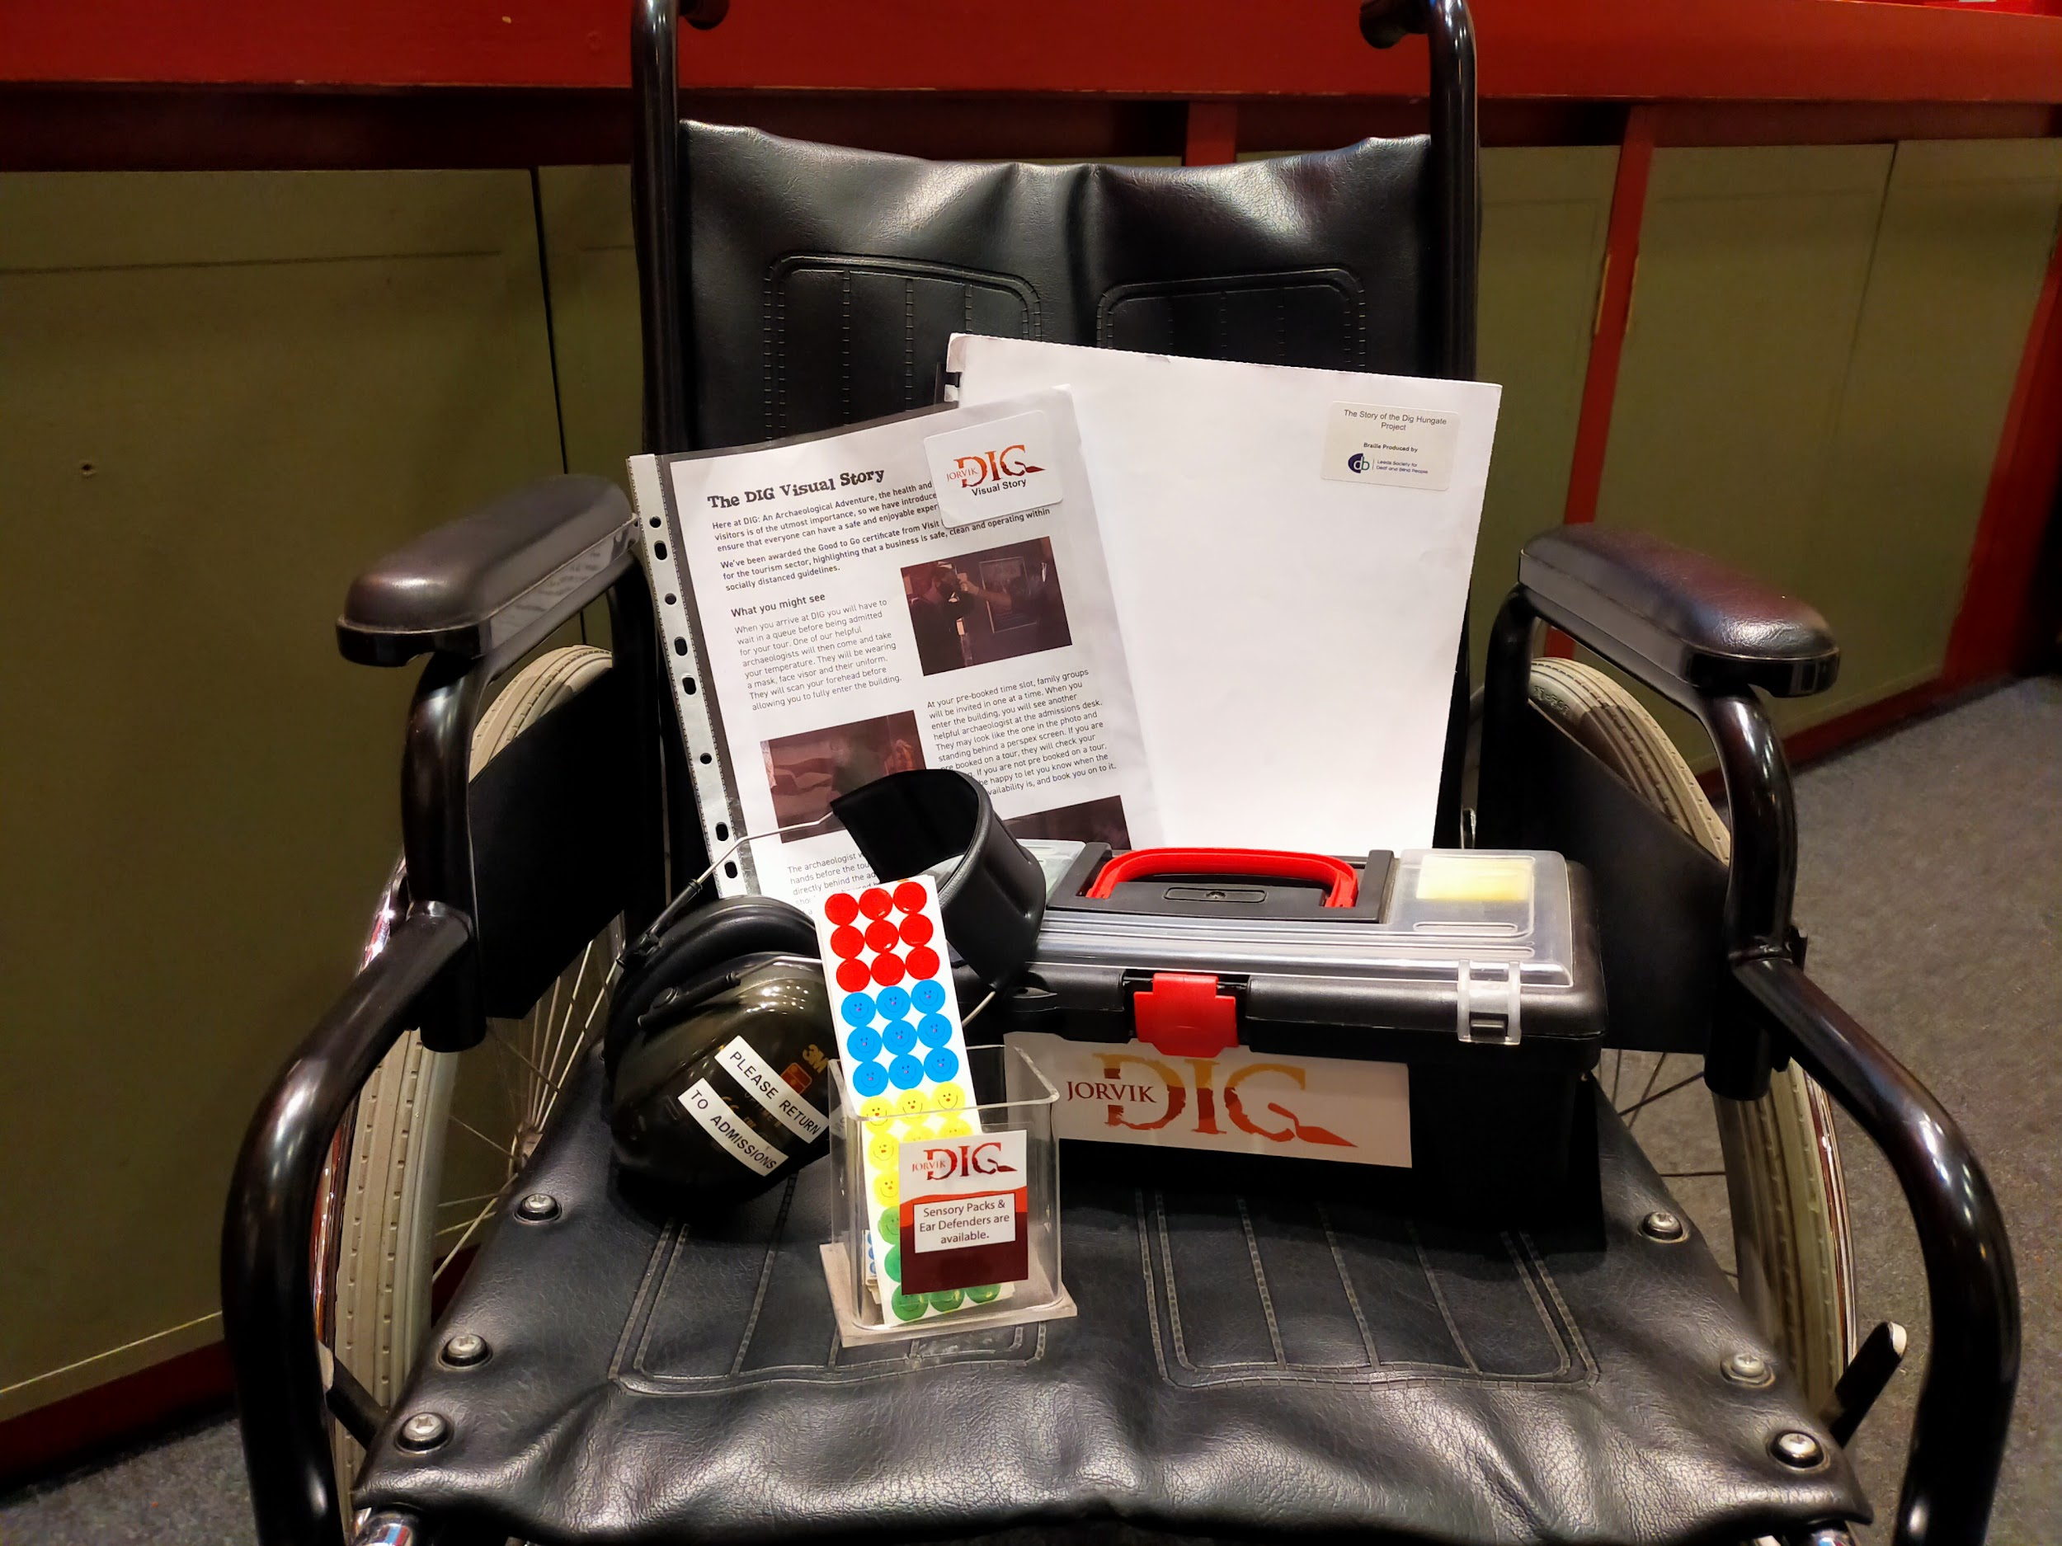
We operate a traffic light sticker system at all our attractions:
- Red sticker = please do not approach me
- Yellow sticker = please answer my questions but let me approach first
- Green sticker = please approach and speak to me
You can pick up the sticker colour of your choice at the front desk.

Shop
Alongside the admissions area is our main shop. We have a variety of items for you to purchase, from books to plushies to plastic trowels. We also sell a number of fidget toys and sensory objects. Prices are clearly marked on small signs but also on stickers on each item. If you’re unsure about something, staff members are always at the desk and happy to help.

There is level access from the main entrance to the shop and the narrowest section is 740mm. Like our admissions area, it has a flagstone floor, so it is not perfectly smooth but it is level. Additionally, metal pillars which support the floor overhead are located within the shop and therefore reduce clearance around the shop. The desk has a low section.

Discover Archaeology - Pod Area
This is where your tour begins. Your tour guide will talk about the tour, explaining how it will work, what to expect, and giving safety instructions. They will then give you an introduction to what archaeology is and what archaeologists do. The tour guide will tell you about various aspects of archaeology, showing you some original artefacts from our excavations, as well as replicas you may be able to handle. This section lasts about 30 minutes.
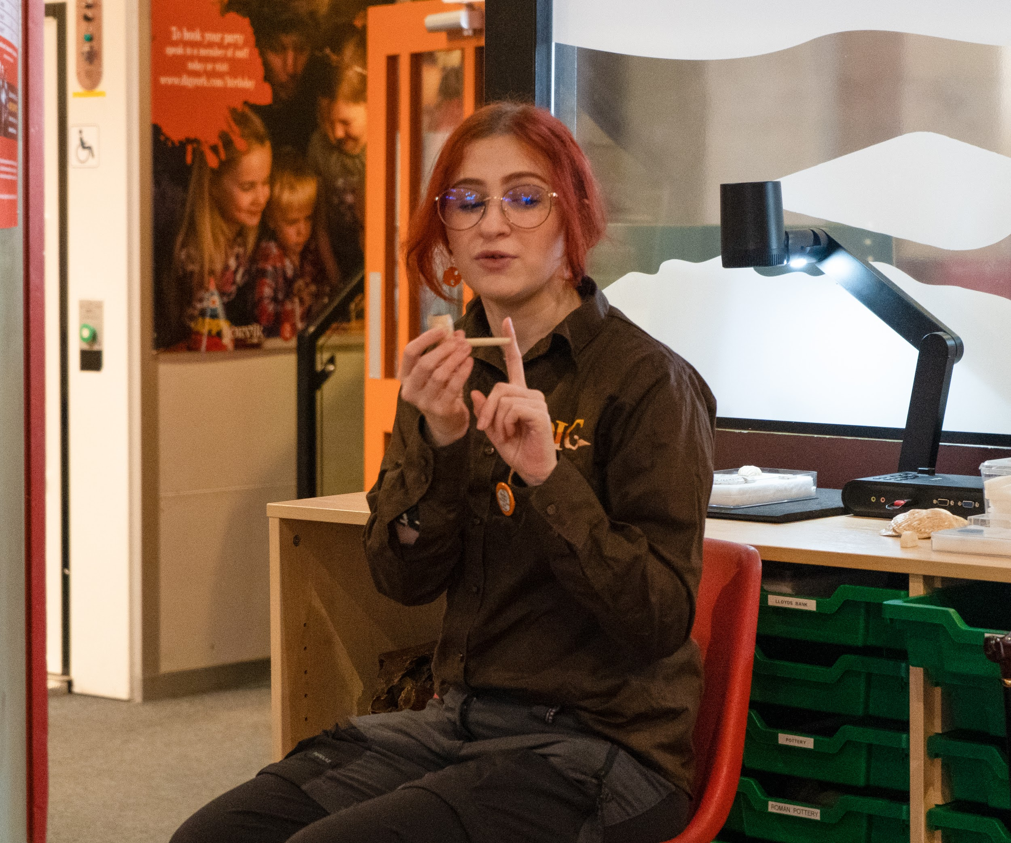
There is level access to this area from the main entrance. The narrowest section is over 1m wide. Everyone is seated at tables that can be easily moved and rearranged - the tables are 680mm high. The chairs are backless stools that are 460mm high. The chairs can be moved to allow access for wheelchair users. The floor is linoleum and level throughout.
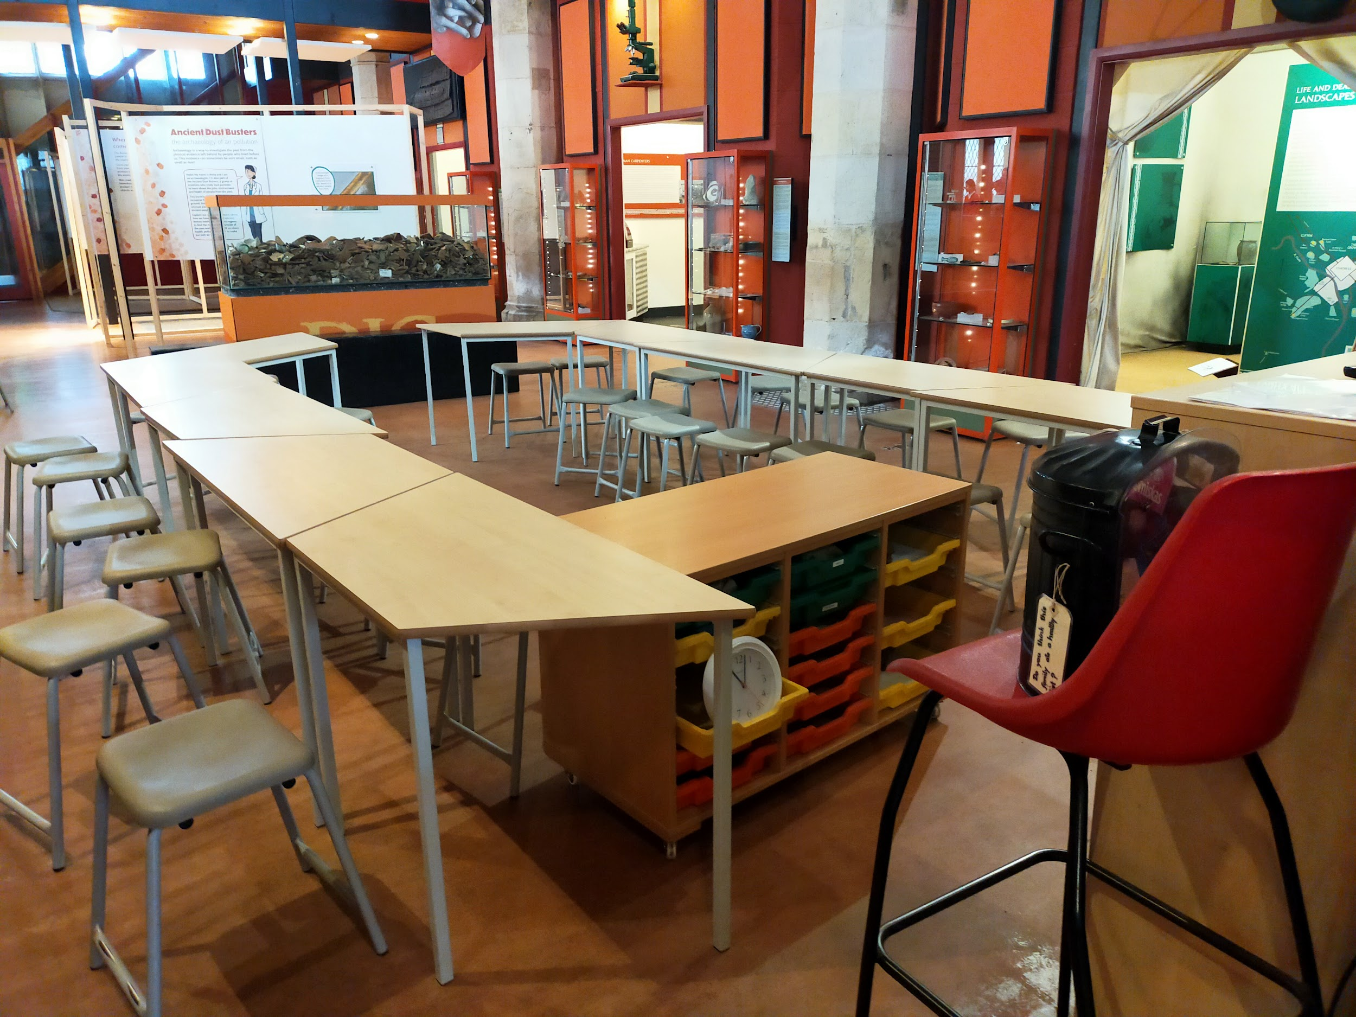

Do Archaeology - Dig Sites
This is the second part of the tour where you can dig around our replica dig sites. Each site represents a different excavation site in York and a different period of time: Victorian Hungate, Medieval Fishergate, Viking Coppergate, and Roman Blake Street. Each dig site is filled with rubber soil covering a textured floor with real and replica artefacts embedded into it. This part lasts about 30 minutes.
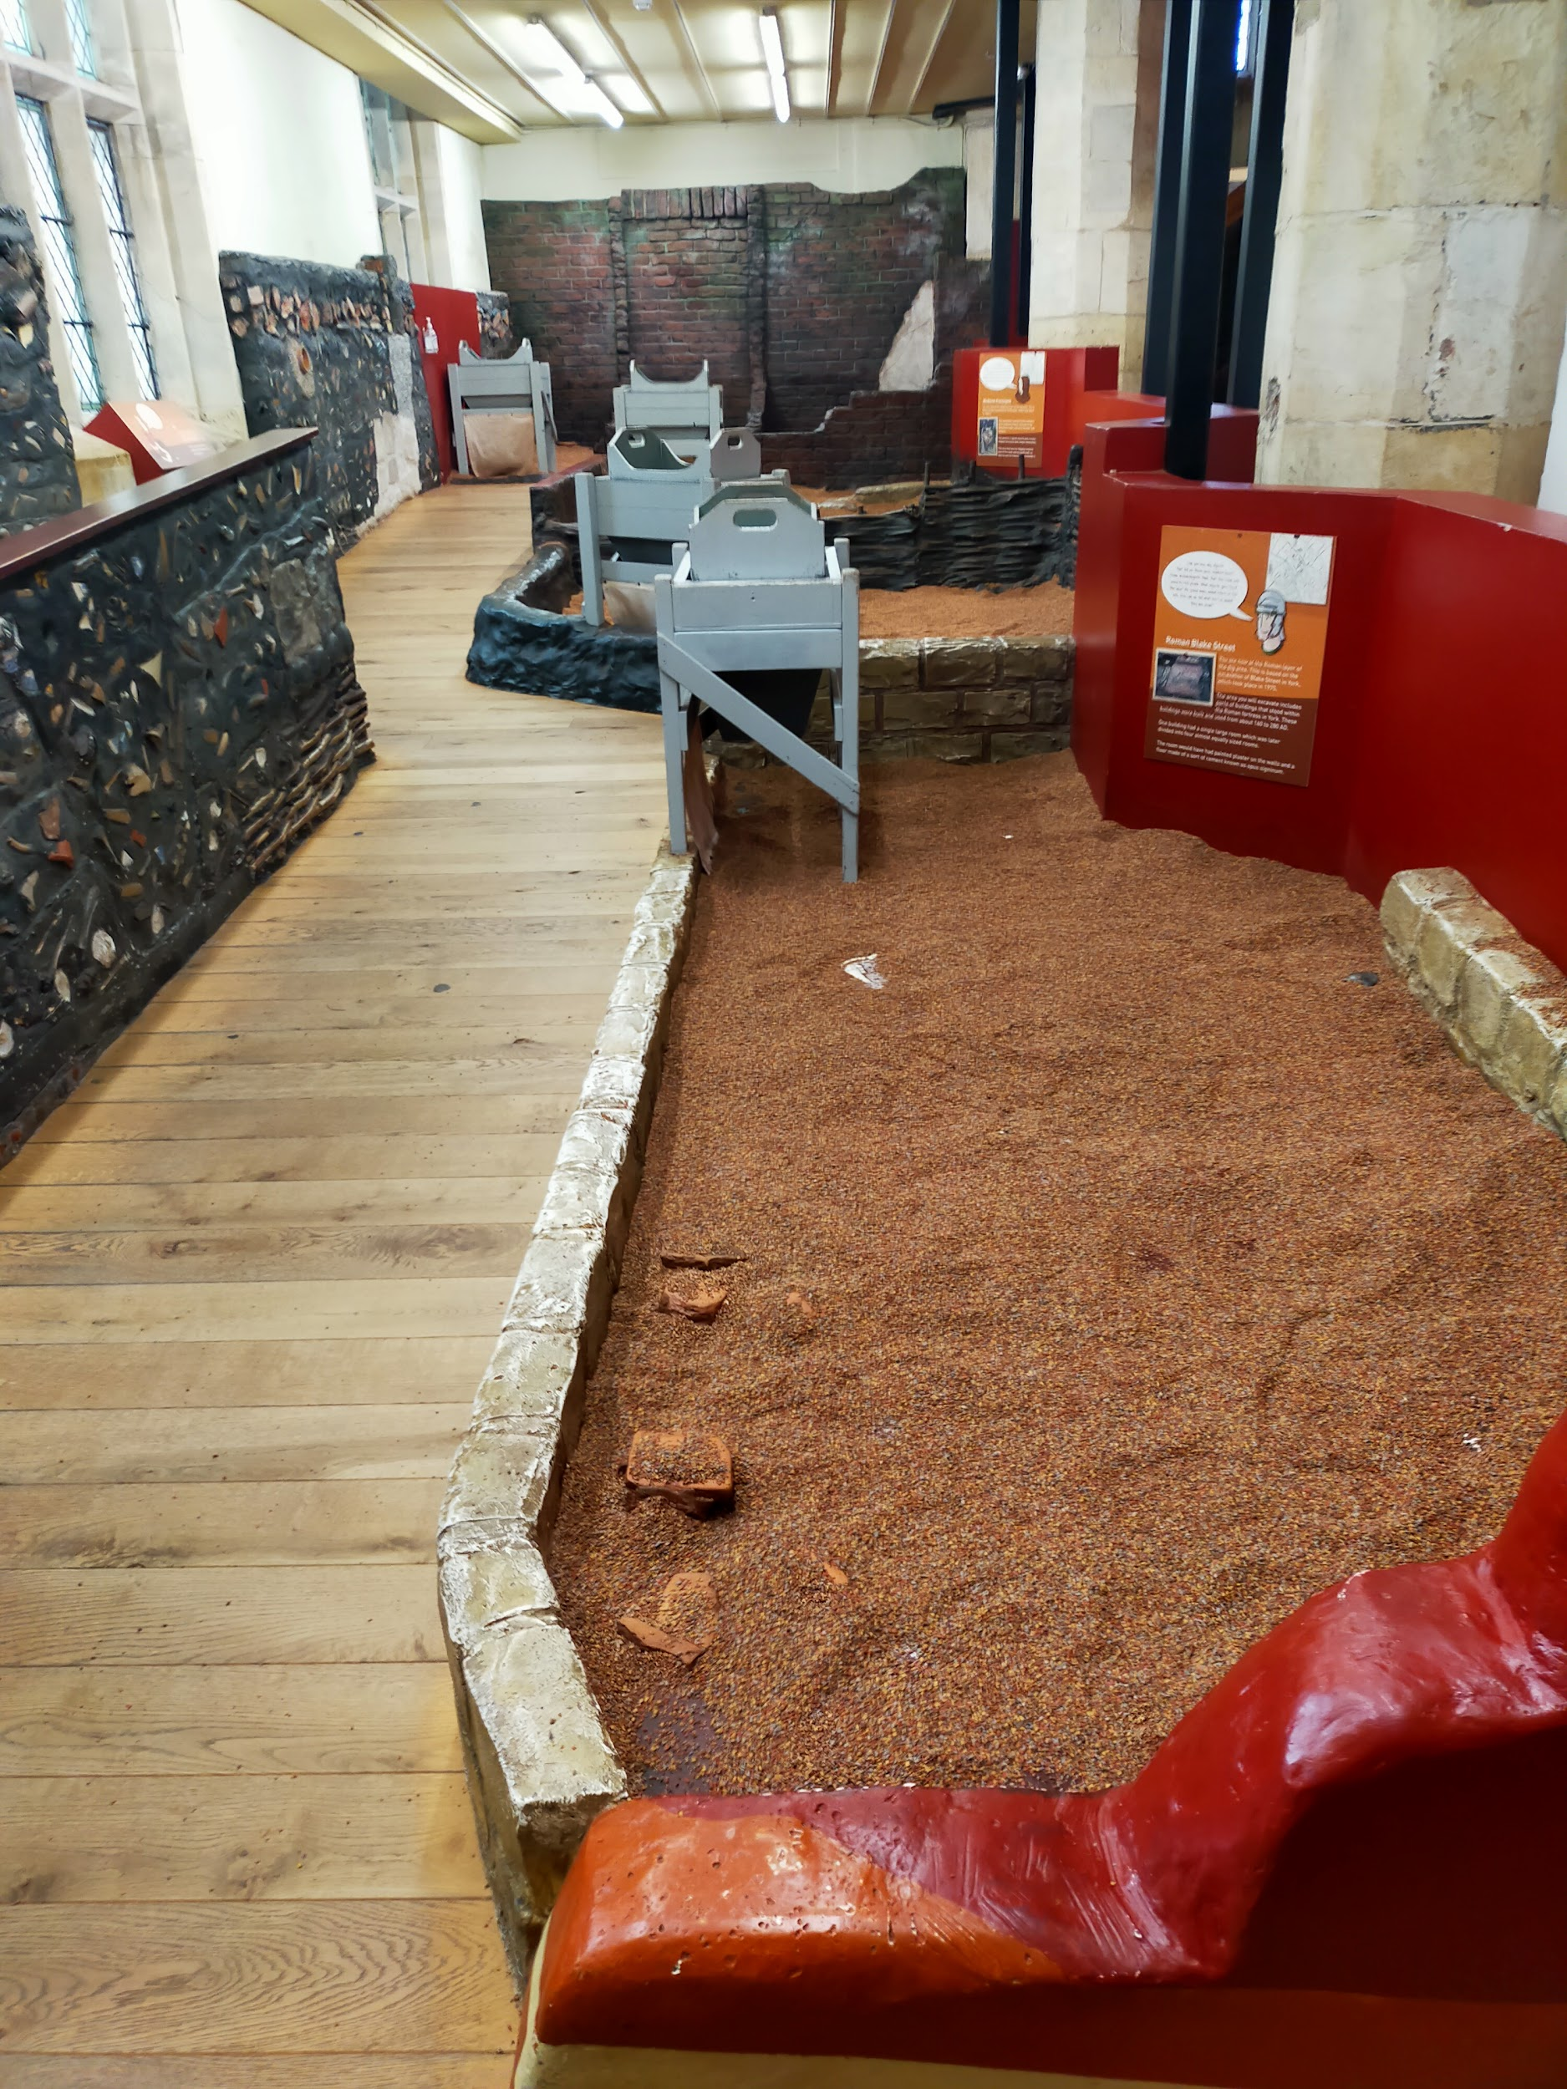
There are low walls on three of the four dig sites, ranging from 100mm to 450mm high. There is a ramp and pathway alongside the digsites made of wood, which is flat, and has two level areas to rest wheelchairs in.
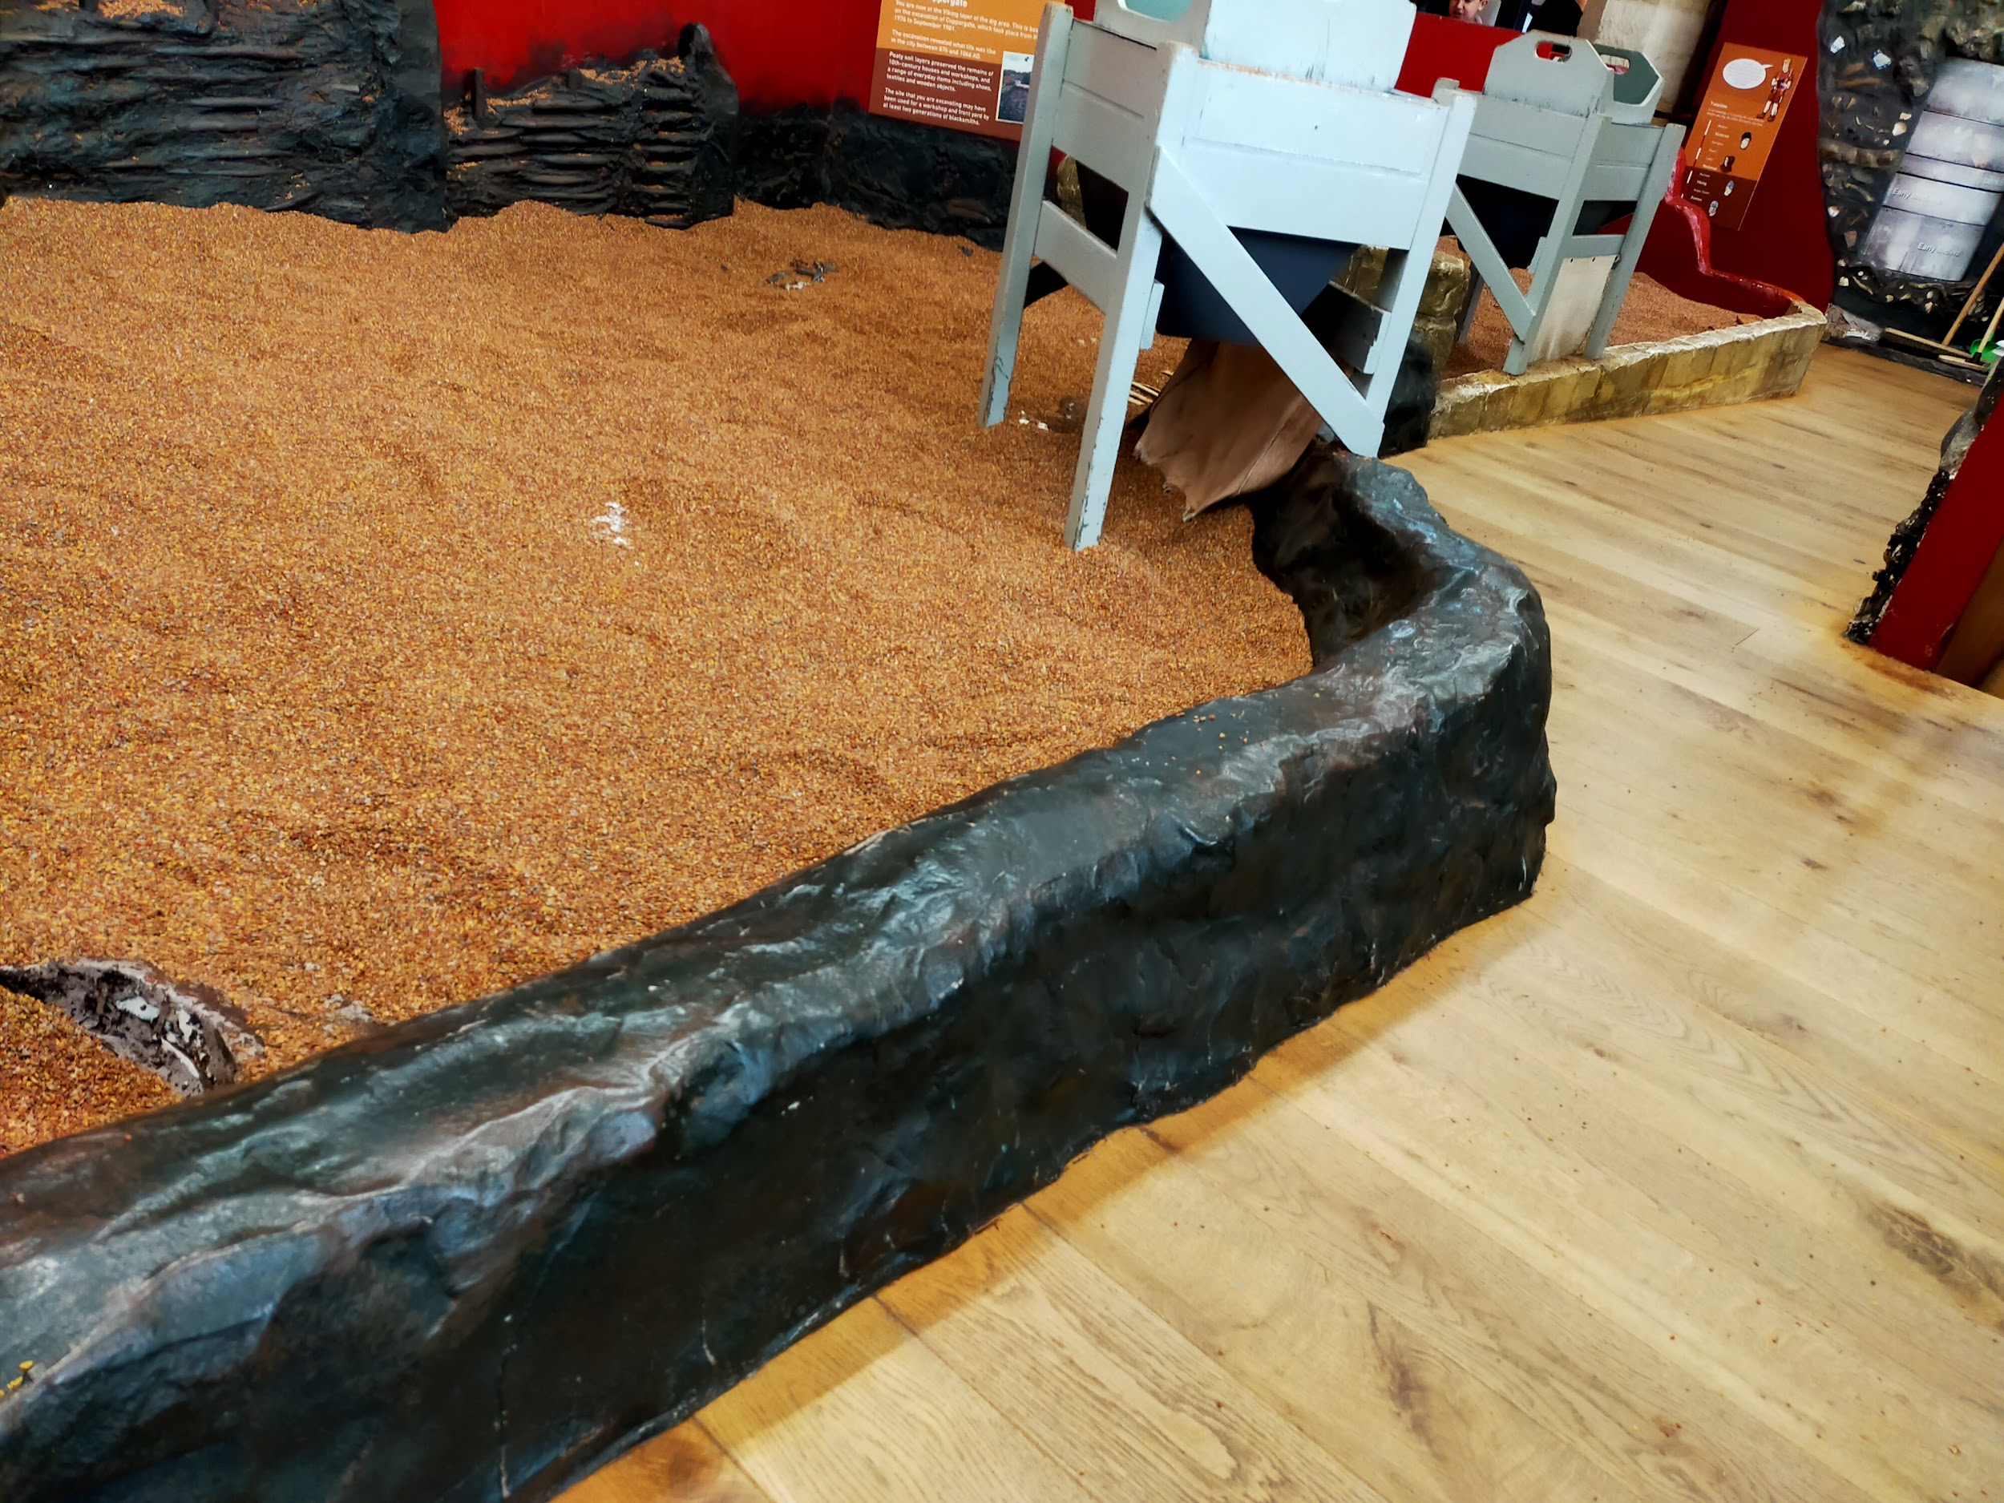
If you want to dig, you’ll be provided with a plastic trowel. Foam kneeling pads are also available to use, as well as long-handled trowels. All trowels and kneeling pads are disinfected after each use.
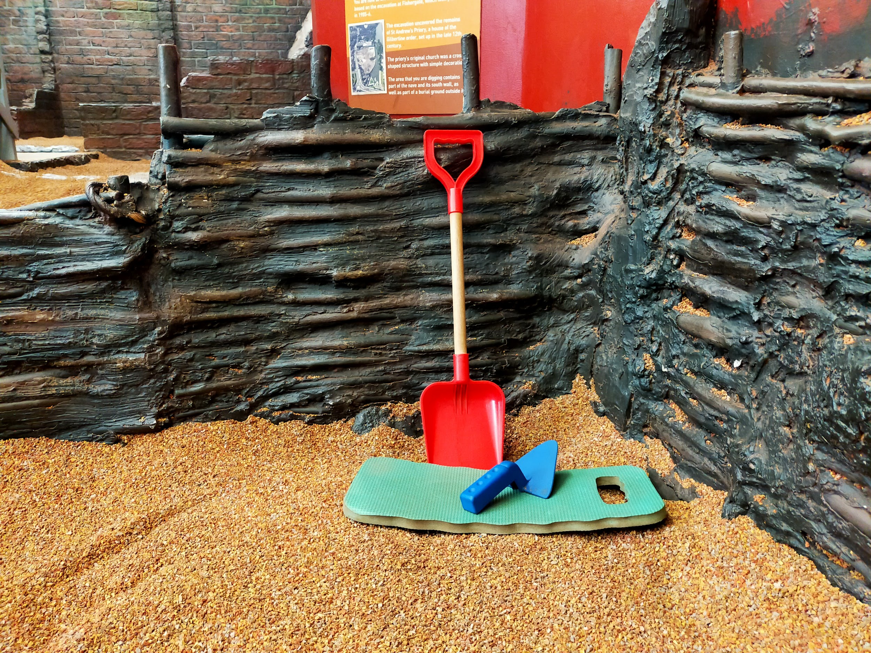
We ask you to keep your shoes on while you’re in the dig sites - but if it would feel better to have your shoes off, let a staff member know and they’ll let you.
There are also sieves at each dig site which are 890mm tall so you can sift through the soil and discover smaller artefacts. Your tour guide may also bring out our handling collection, which has real artefacts as well as replicas from the excavations represented in our dig sites.
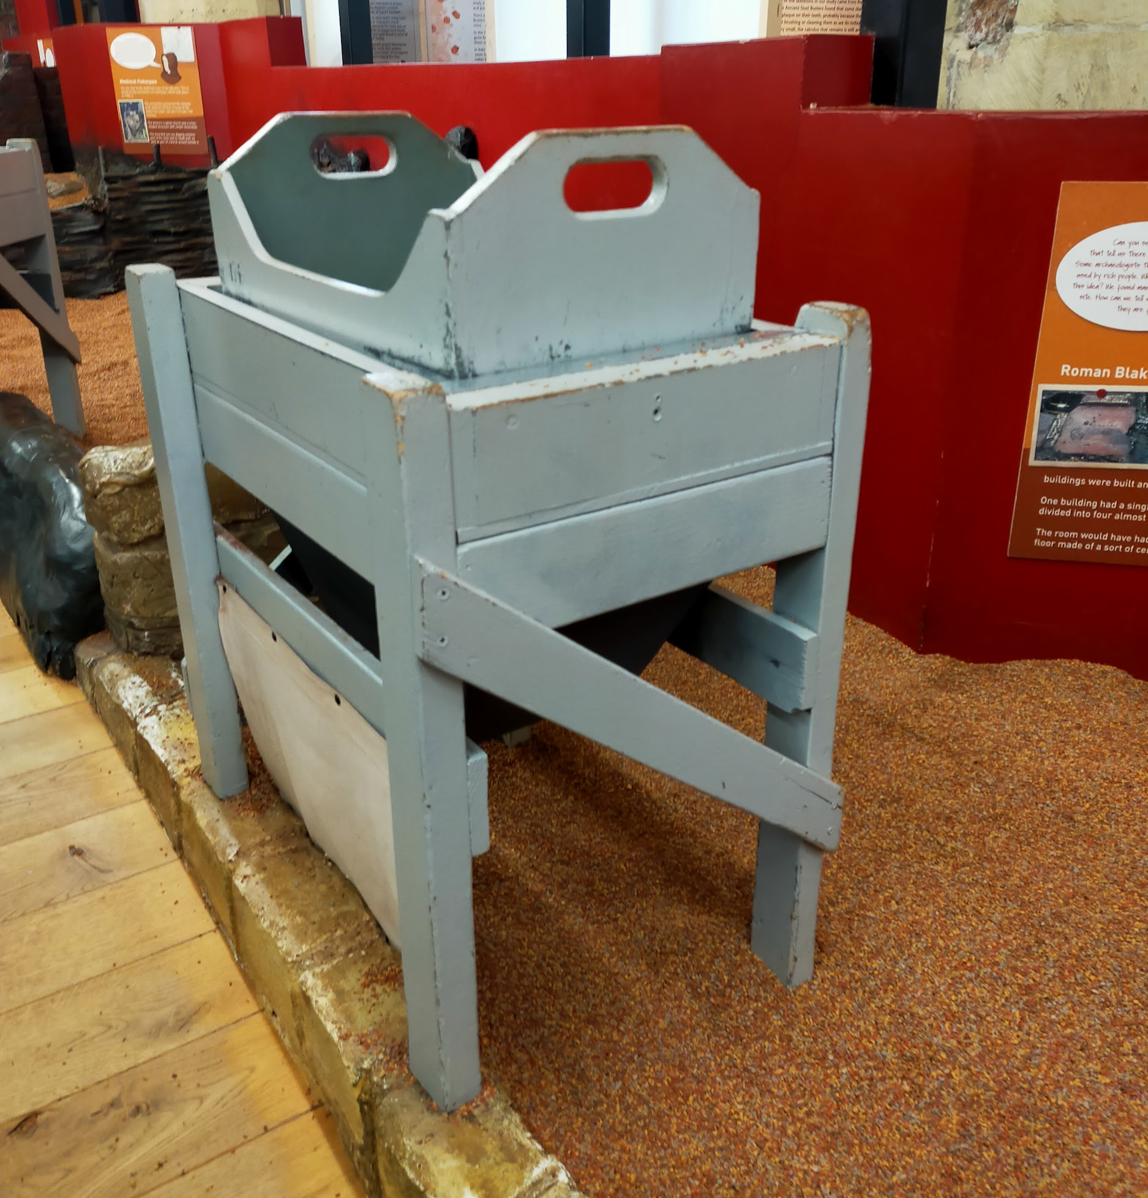
We have folding chairs available in this area for you to use and all display information is at a low height.
Allergy note: in the Viking site, there are oyster shells and we cannot guarantee there is no cross-contamination to the other dig sites. Anyone with a severe shellfish allergy should alert a staff member. We can provide non-latex gloves or find another suitable activity.
There is level access to this area from the front door. There is a permanent ramp, and the narrowest section is 825mm wide.

Little Diggers - Under 5's Area
Little Diggers is our Under 5's area where any younger visitors can either play during the first tour section or after their tour. There are a number of interactive toys and sensory items including calming sensory lights if needed.
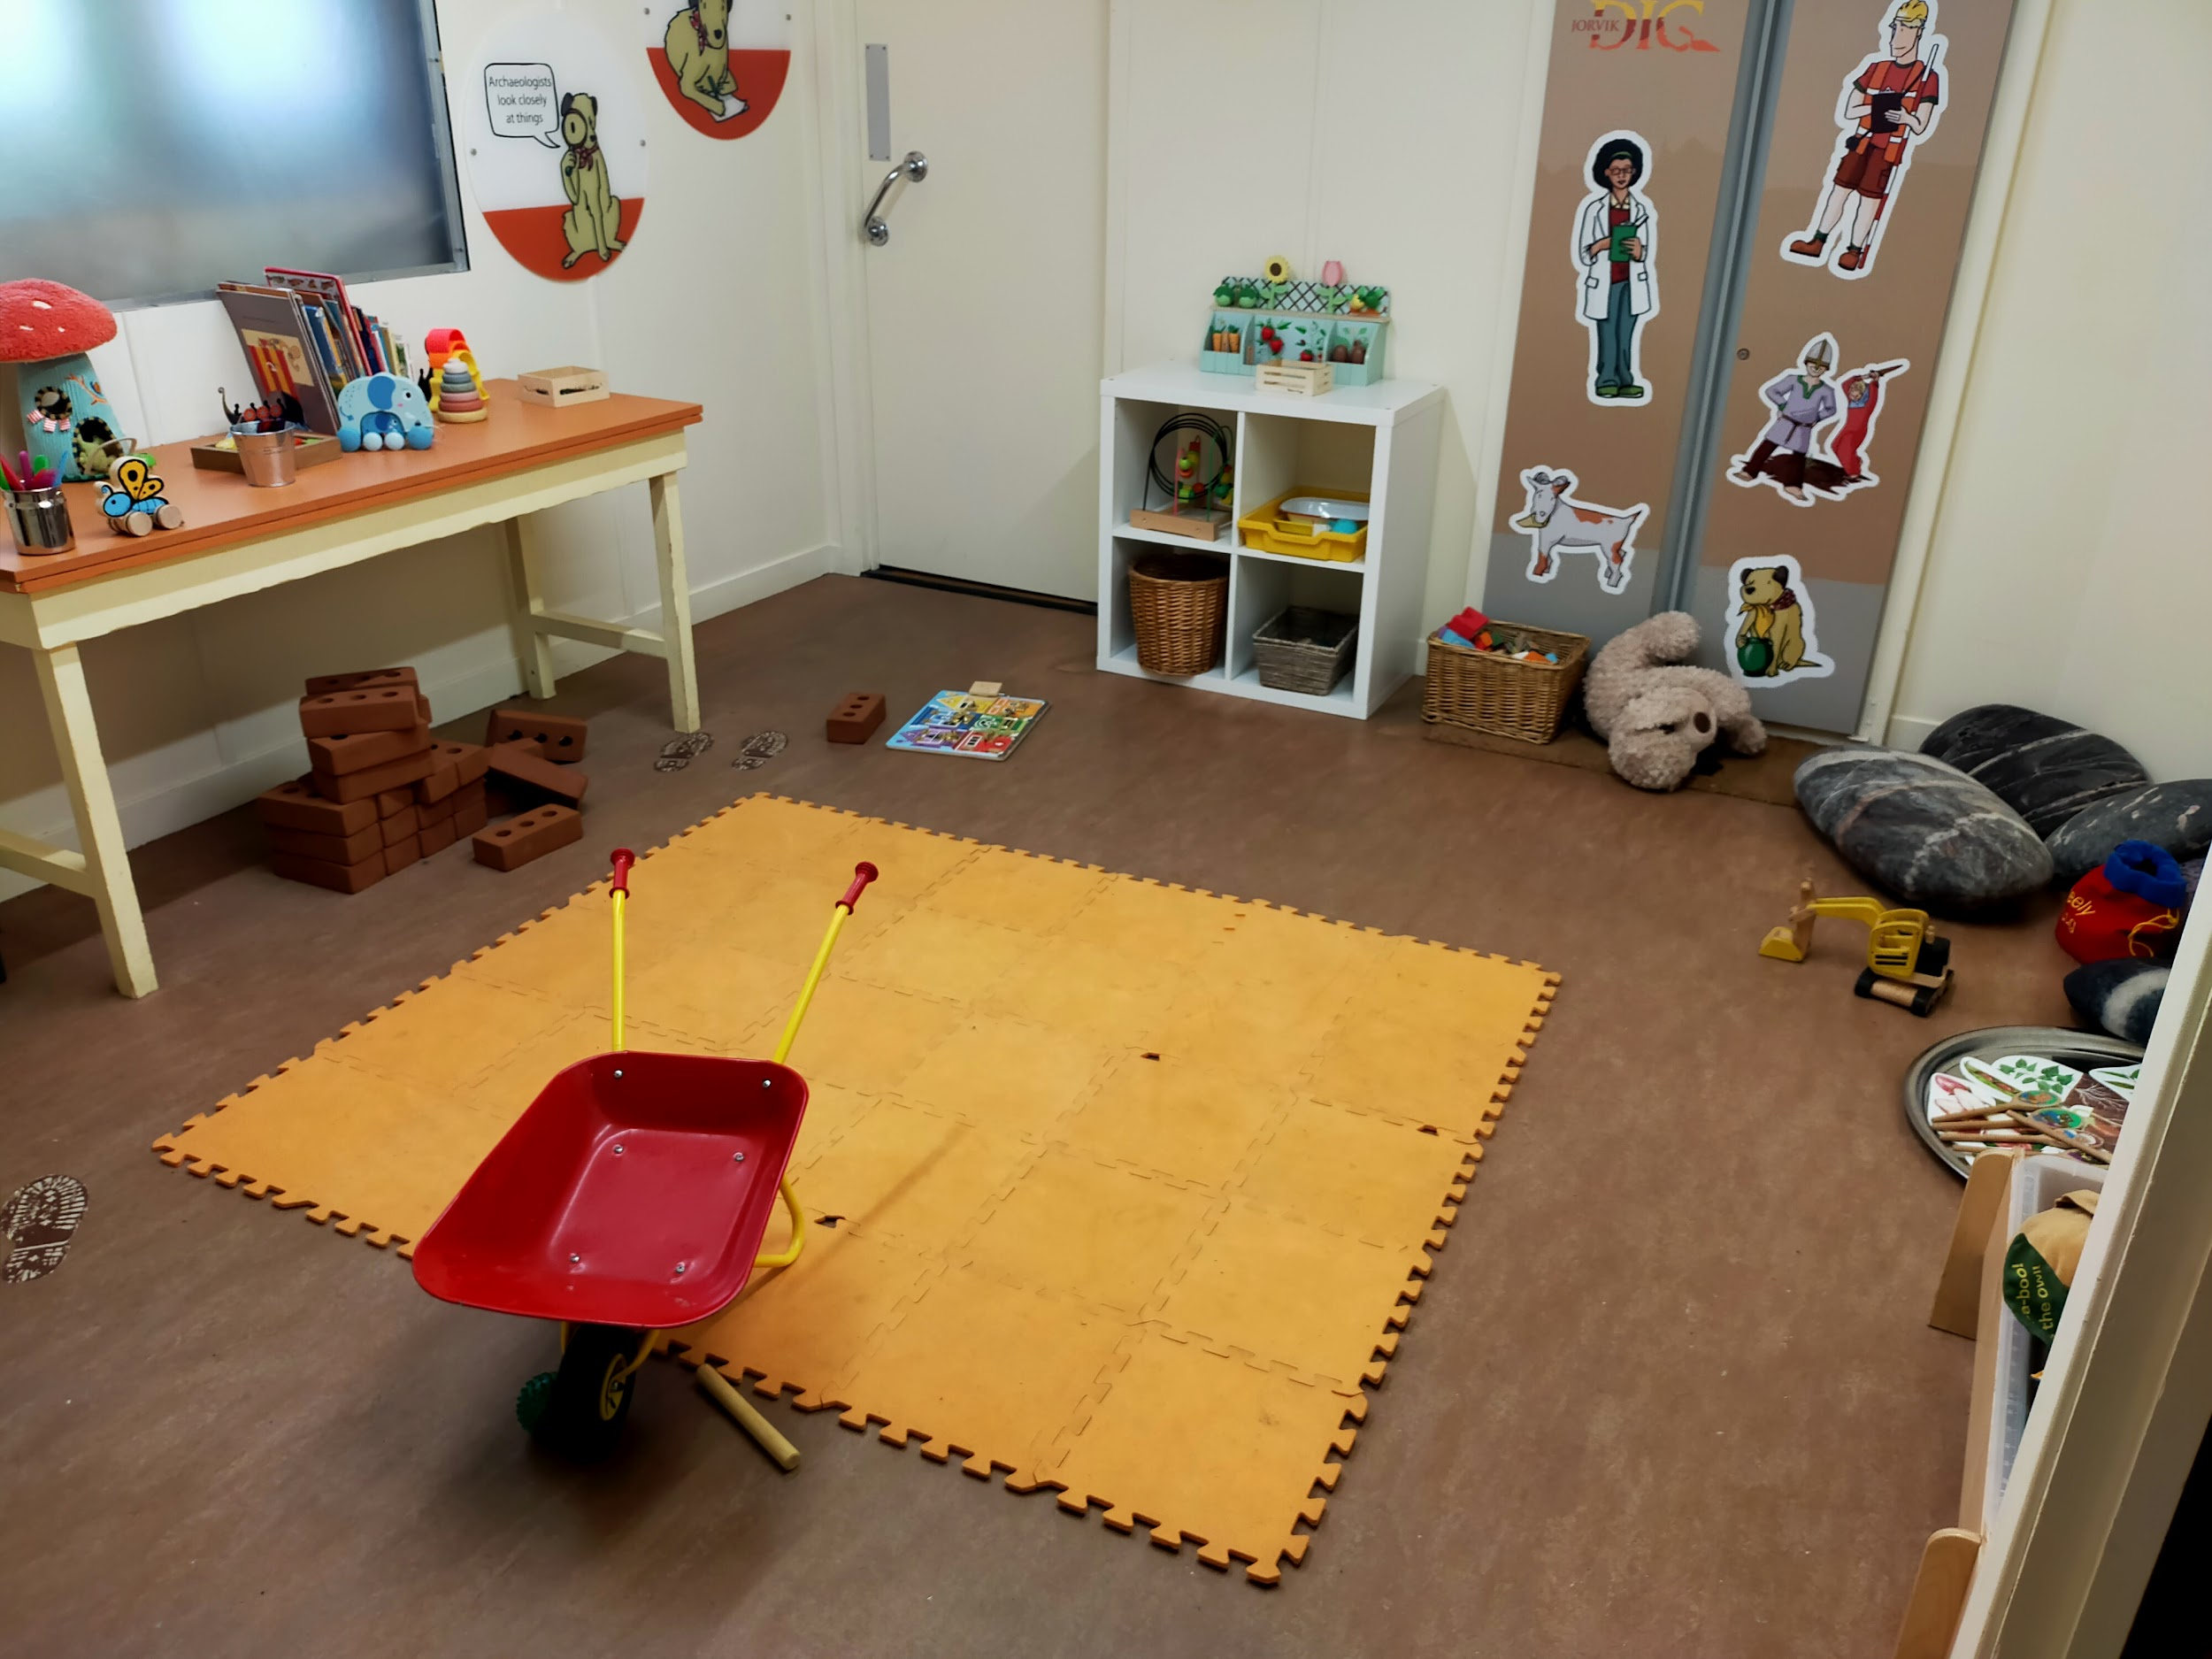
From the main entrance to this area, there is level access. The door is 930mm wide and swings outwards. The floor is linoleum and level throughout, with throw blankets, foam pads, and pillows scattered around the room.
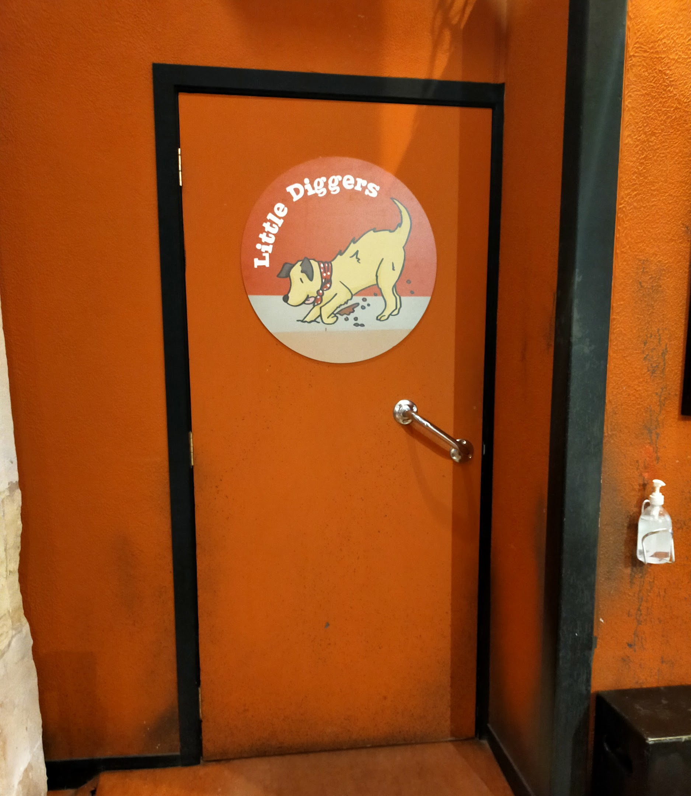

Nave Exhibition
In the nave of the church, there is a temporary exhibition space. These exhibitions are usually related to archaeology or the York Archaeological Trust's work in the community.
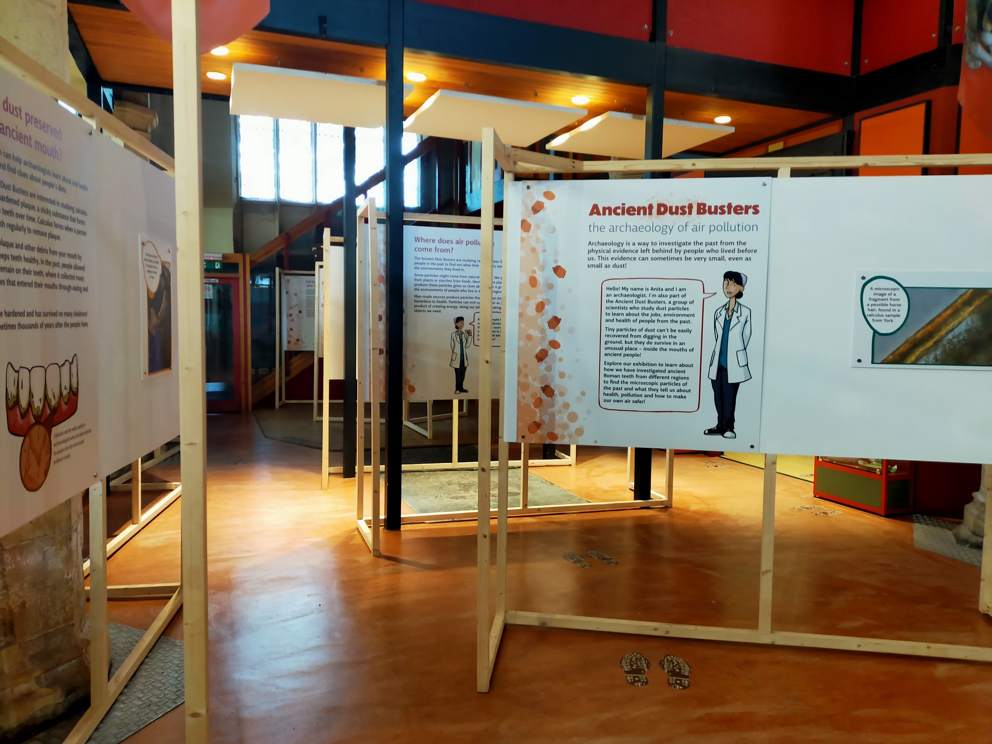
From the main entrance to this area, there is level access. The narrowest part of the route is 1200mm wide. The exhibition space has a linoleum floor and is level throughout - however at the back of the nave there is a raised wooden platform. The edges of the platform are angled and the platform is 30mm high.
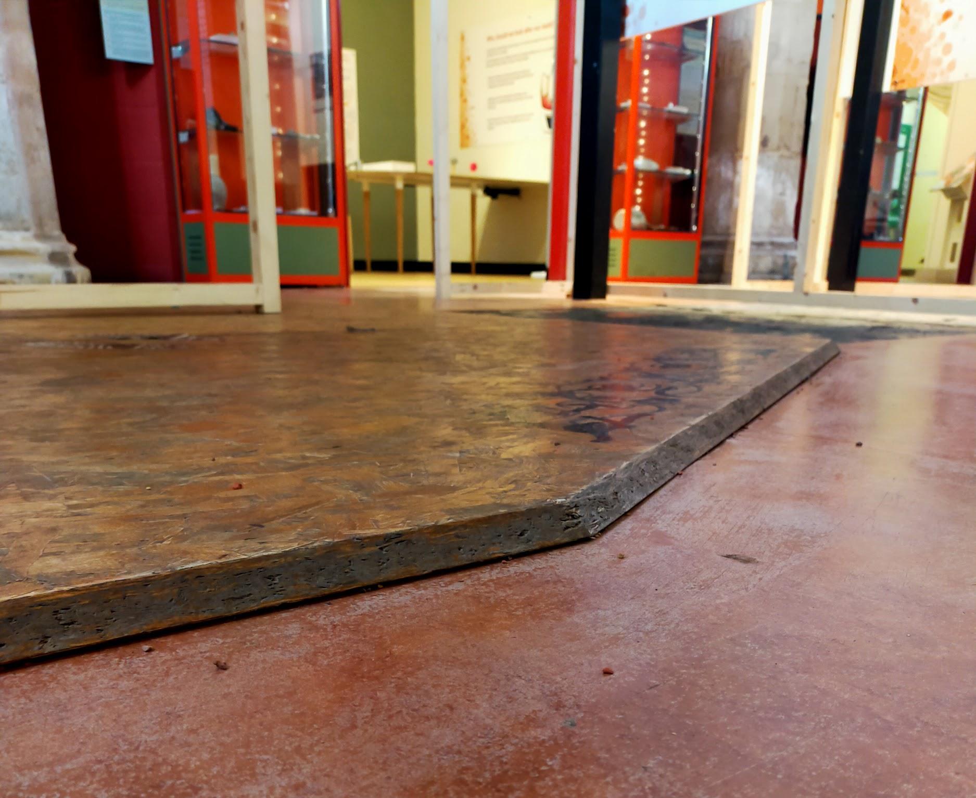

Exhibition Galleries
Our two exhibition galleries hold our newest installation: Eboracum - Life and Death in Roman York. There is a collection of Roman-era finds from excavations around the city, as well as some activities and a chance to sort real Roman pottery. There is also a human skeleton on display. There are two videos (no sound): one is about the 2017 Newington excavation and the other is a digital facial reconstruction of the skeleton that is on display.
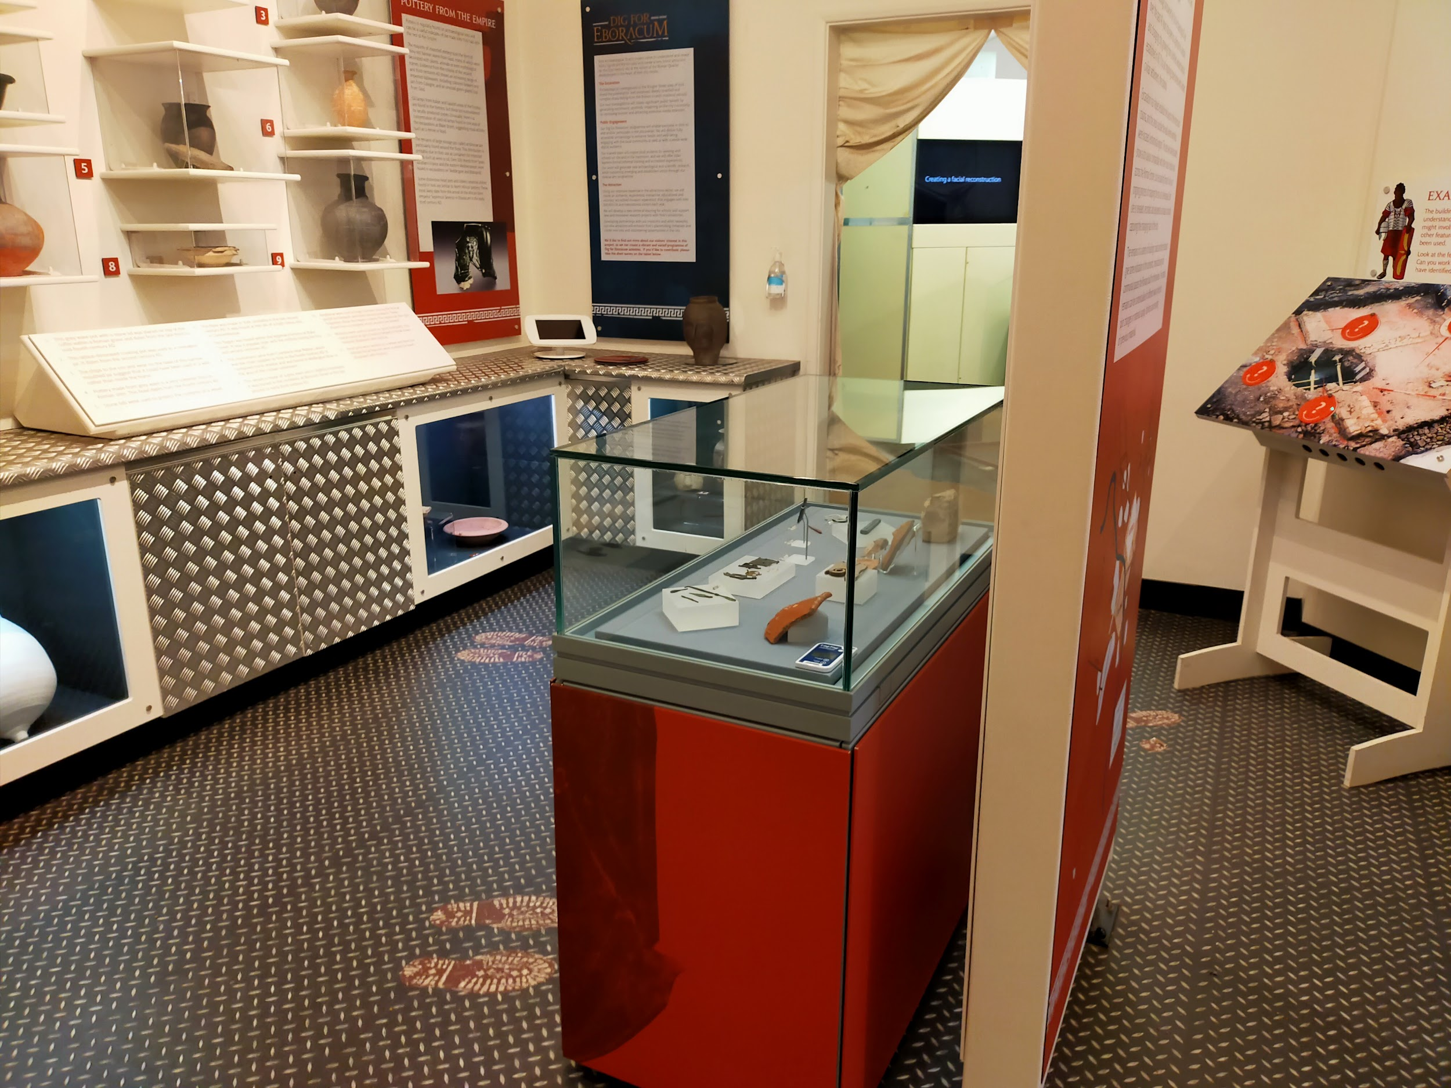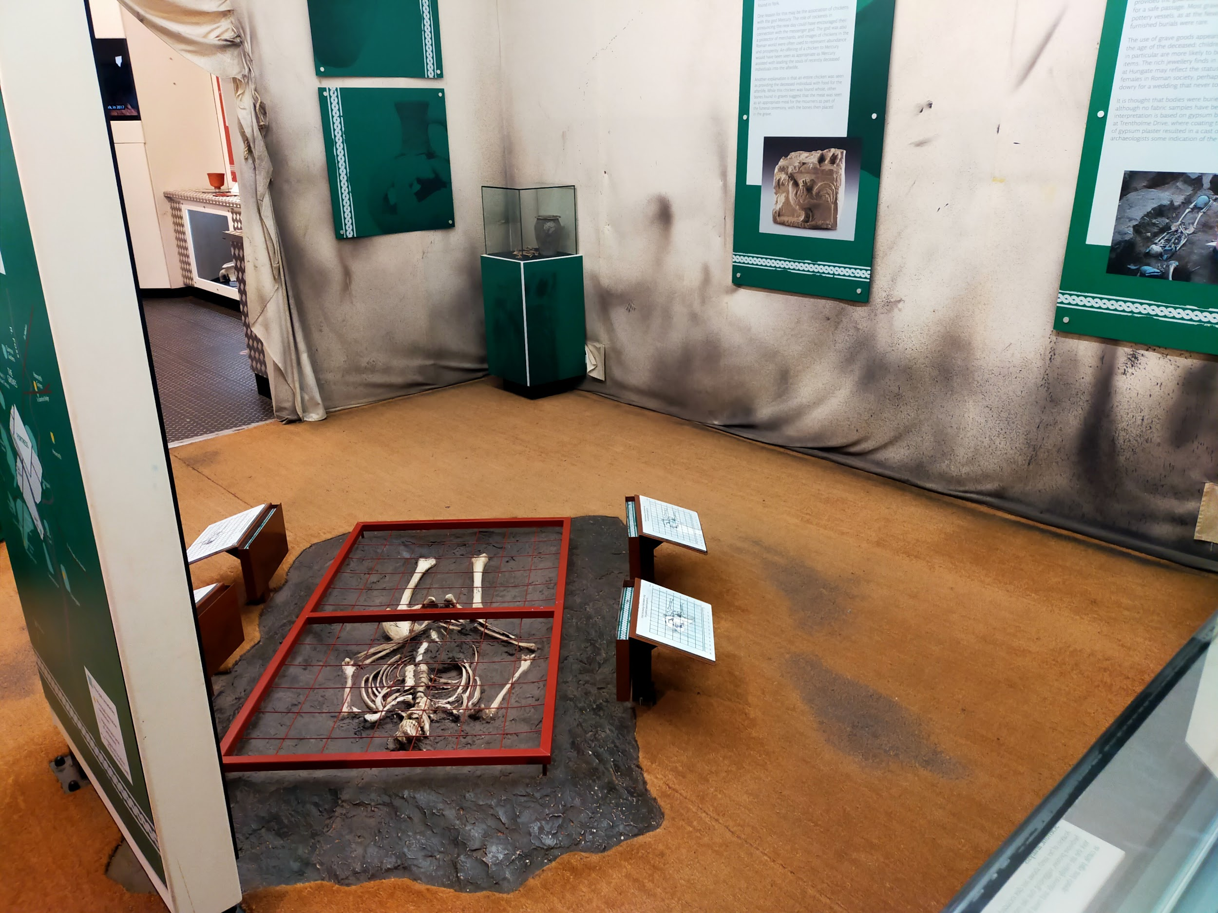
Please note: there are human remains on display in the gallery closest to the pod area. This gallery can be avoided if desired.
From the main entrance to here, there is level access. The narrowest part of the route is 580mm. The first room is carpeted, while the second room is tiled. There is a small lip between the two rooms as the flooring changes.
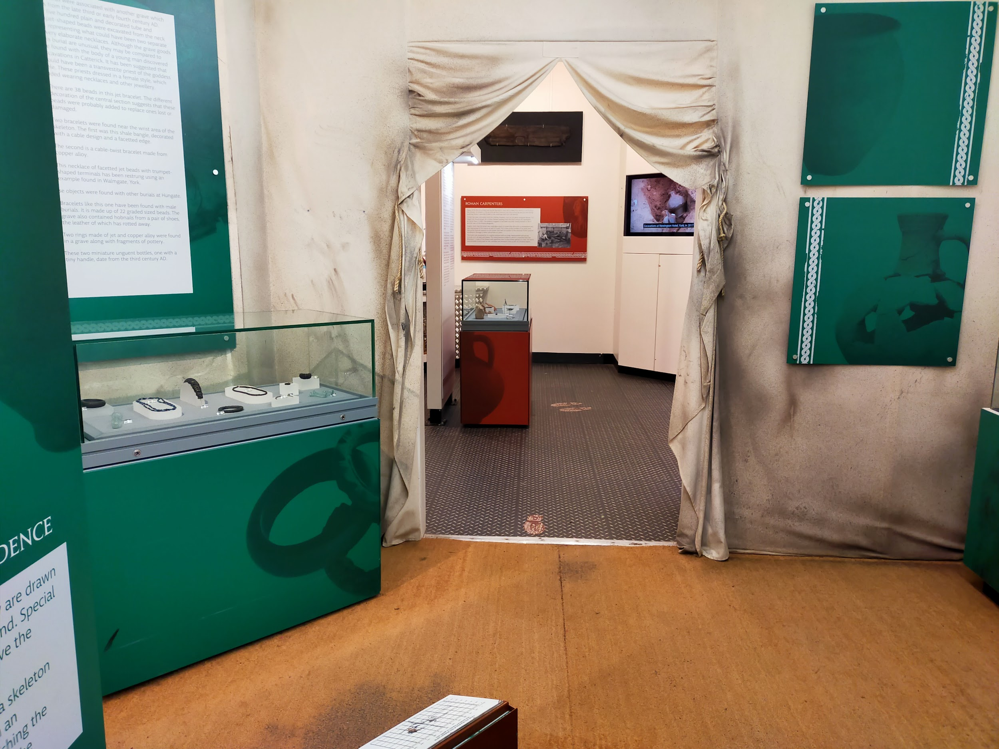

Community Gallery
Our community gallery is a temporary exhibition space that changes regularly. Hands-on activities are there, as well as a video and audio description of the text panels. The table in the room is 700mm high and has space for wheelchair users to pull up to. The floor is wooden and level throughout.
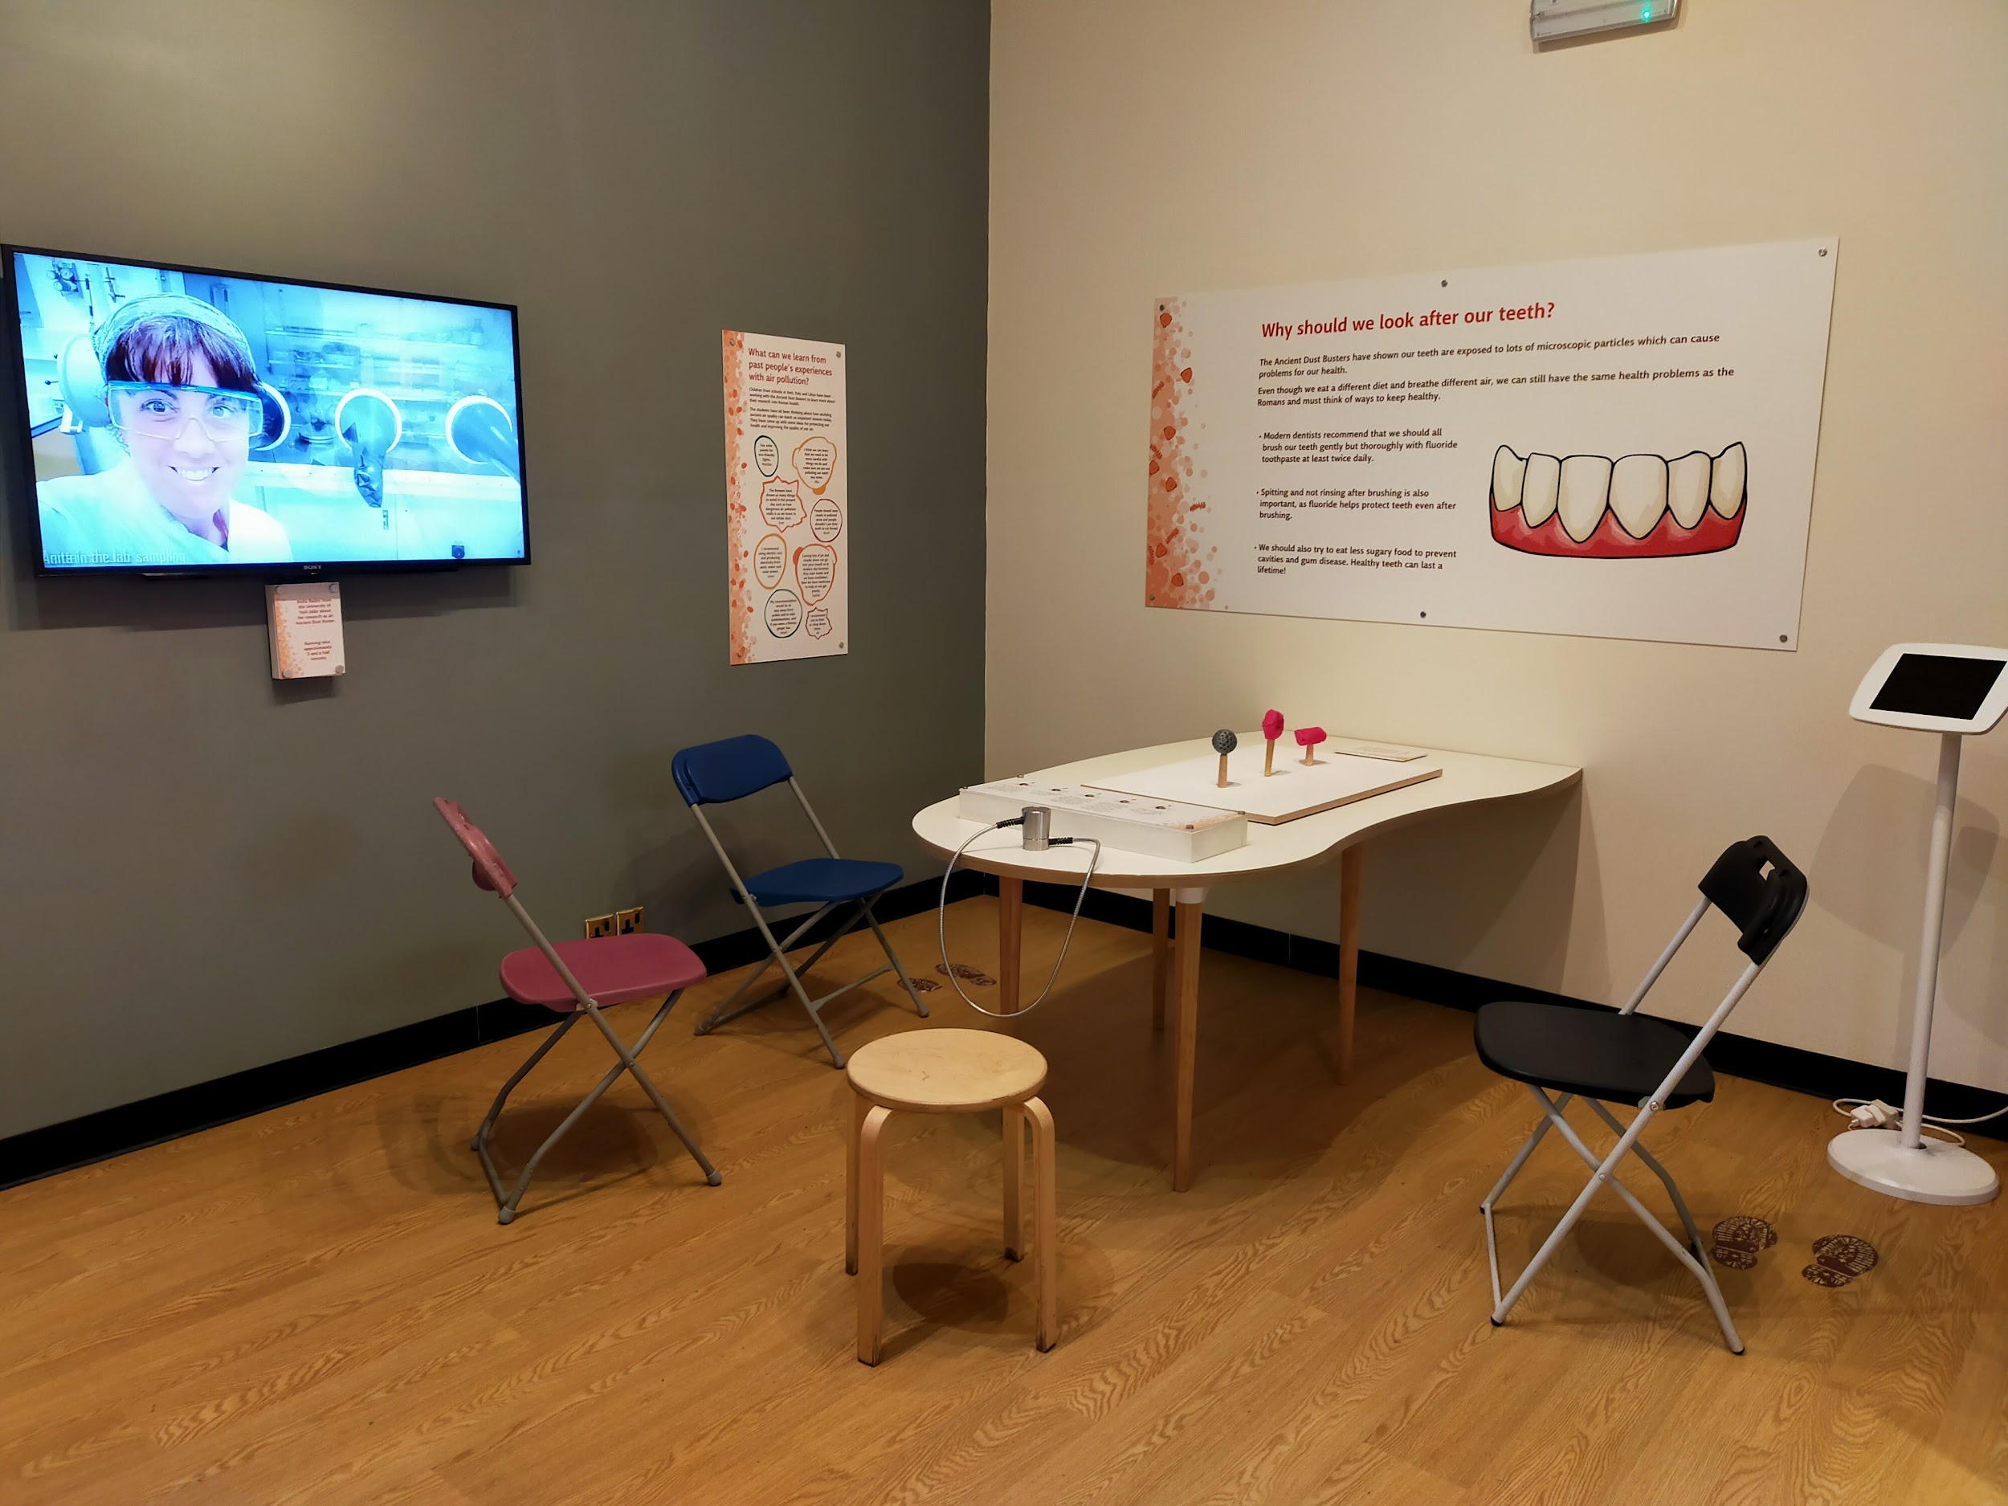
From the main entrance to here, there is level access. The route is at least 1000mm wide.
Please note: this exhibition changes several times a year and some media may change with each new instalment.

Public Toilets
We have three sets of toilets at DIG: a single accessible toilet, a women’s toilet with two stalls, and a men’s toilet with two urinals and one stall.

Accessible Toilet
Our accessible toilet needs a RADAR key to be opened. You can use your own or ask for our key at the front desk.
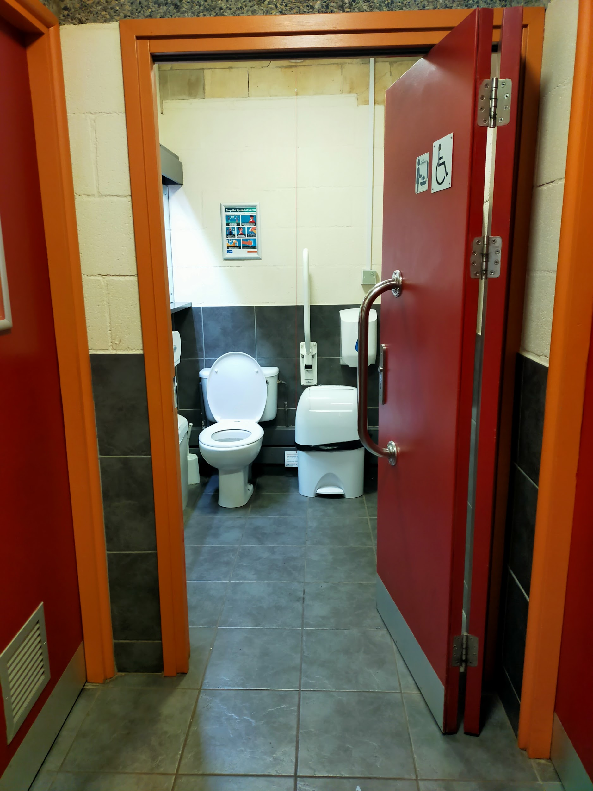
The narrowest part of the route is the toilet door, which is 930mm wide. There is a permanent grab rail on the right hand side of the toilet, and a moveable grab rail on the left hand side. There is 830mm at the side of the toilet with 1130mm in front of the toilet. The toilet seat is 420mm. The floor is tiled and level throughout.
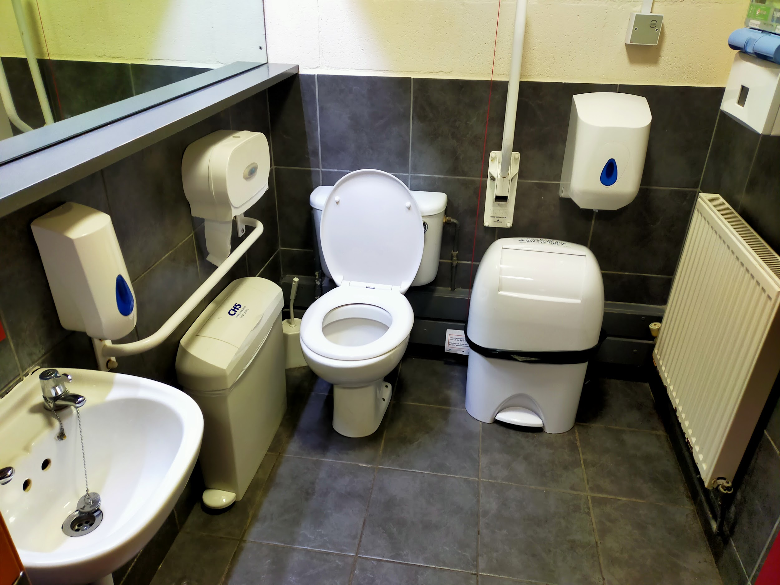
It is checked by the duty manager every hour and has hand sanitiser as well as hand washing facilities. It uses hand towels instead of hand dryers. There is a sanitary waste bin and an incontinence waste bin, as well as a shelf under the mirror that is 1140mm off the ground.
The nearest Changing Places toilet is at:
EXPLORE York Library
Museum Street
York
YO1 7DS

Public Toilet - Women’s
The women’s toilet is located on the left hand side. There are two cubicles inside, as well as handwashing facilities.
The outer door is 750mm wide and swings inwards. The cubicle doors are 650mm wide and swing inwards. There are two sinks and there are hand towels but no powered hand dryer.
There are sanitary waste bins in both cubicles.

Public Toilet - Men’s
The men’s toilet is located on the right hand side. There are two urinals inside and one cubicle, as well as handwashing facilities.
The outer door is 750mm wide and swings inwards. The cubicle door is 650mm wide and swings inwards. There are two sinks and there are hand towels but no powered hand dryer.
There is a sanitary waste bin in the cubicle.

First Floor
Our first floor is mostly offices, so you won’t be visiting most of this level, but there are two areas you might visit:
- Classroom
- Lunch room
There is a lift between levels and you’ll need to go through one door to get to the classroom and the lunch room. The door is 850mm wide and swings inwards. We keep this door propped open whilst we’re open.
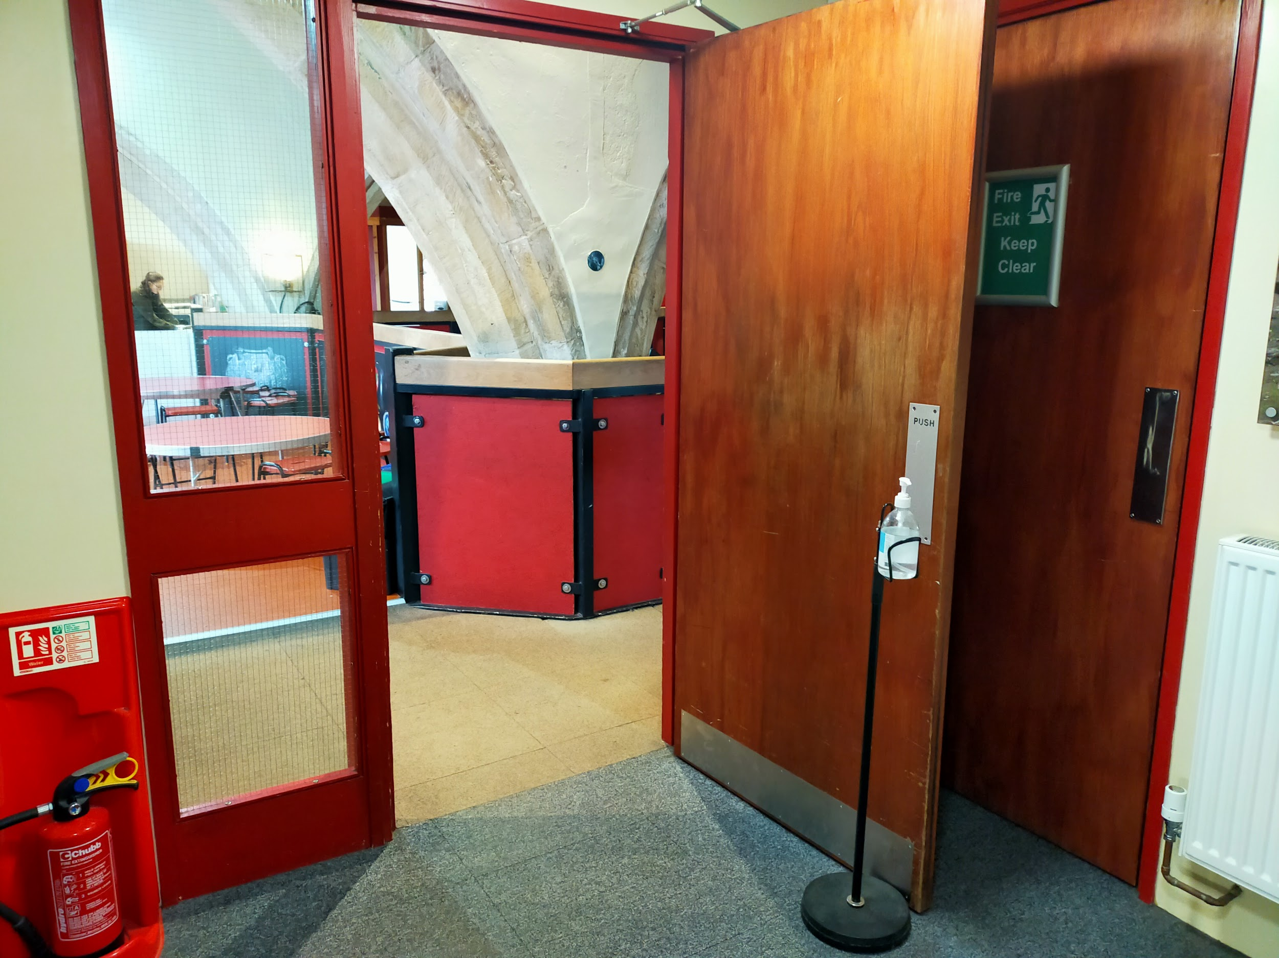
There is a staircase to get to this level as well. There are 19 stairs, with two landings, that are 180mm high. The stairs are 810mm wide and there is a handrail on the right hand side as you’re going up.
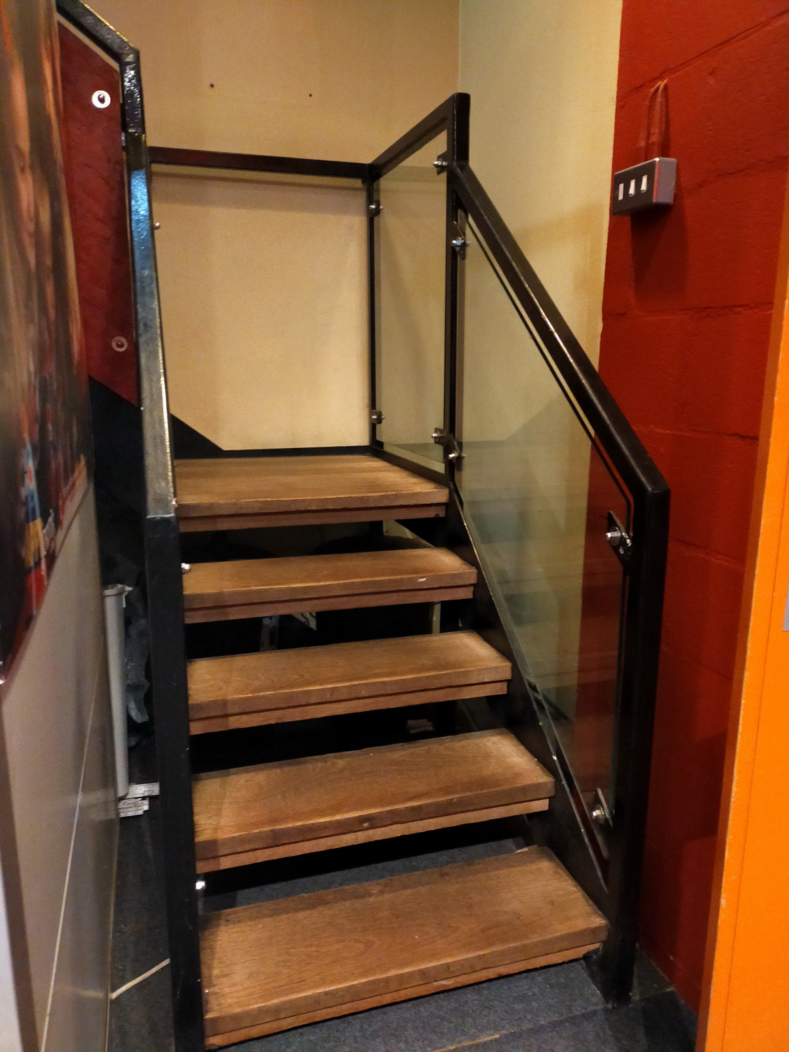
There is level access throughout the area, and most of the flooring is tightly woven carpet, except the lunch room which is linoleum.

Classroom
Our classroom is where we run our workshops for schools. When it is not being used for schools, it’s our quiet space if you need it.
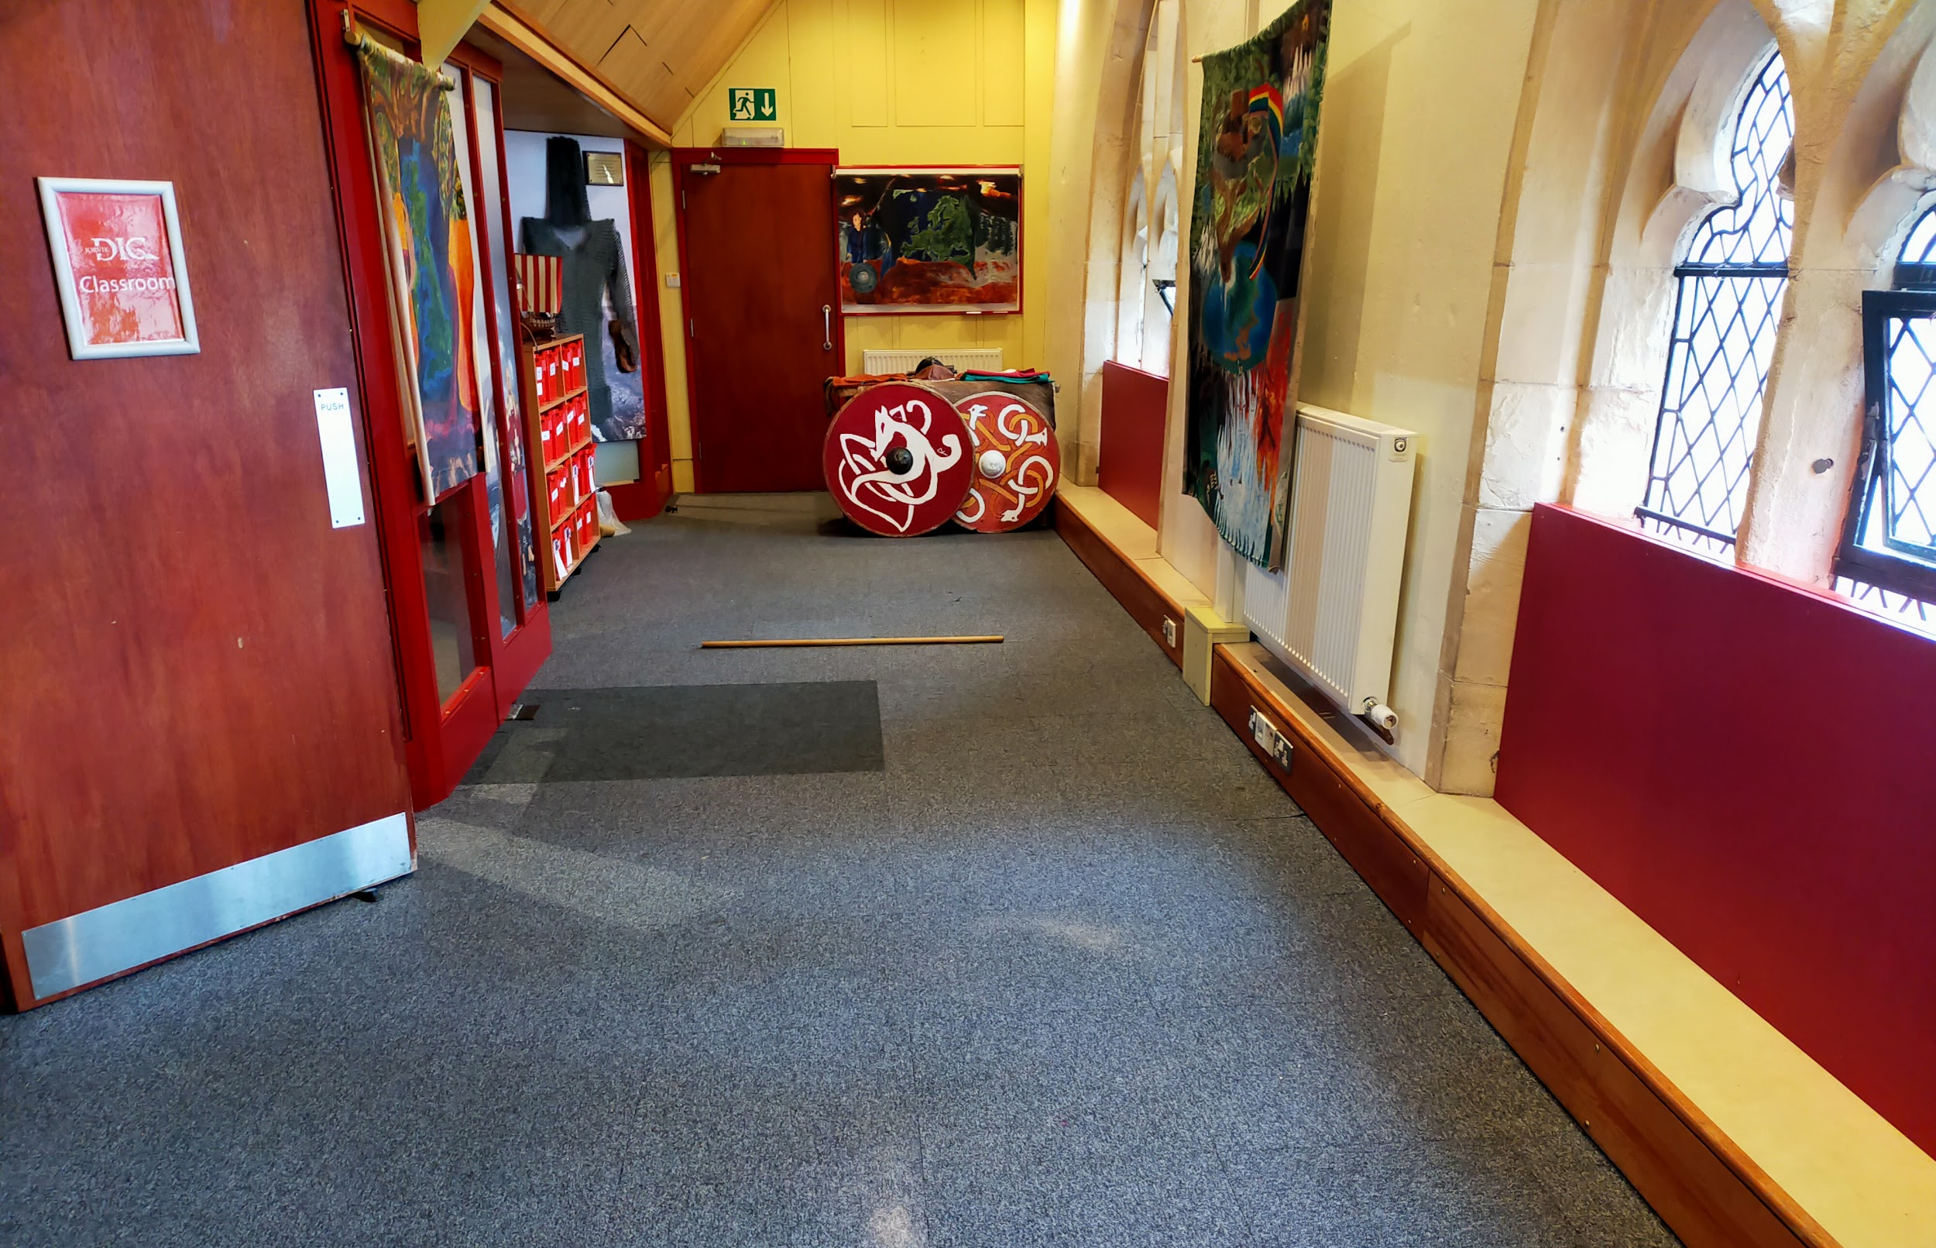
From the lift to here, there is level access. There is a door into the classroom that’s 830mm and swings inwards. If you’re here for a workshop, a staff member will be there to hold the door open for you.
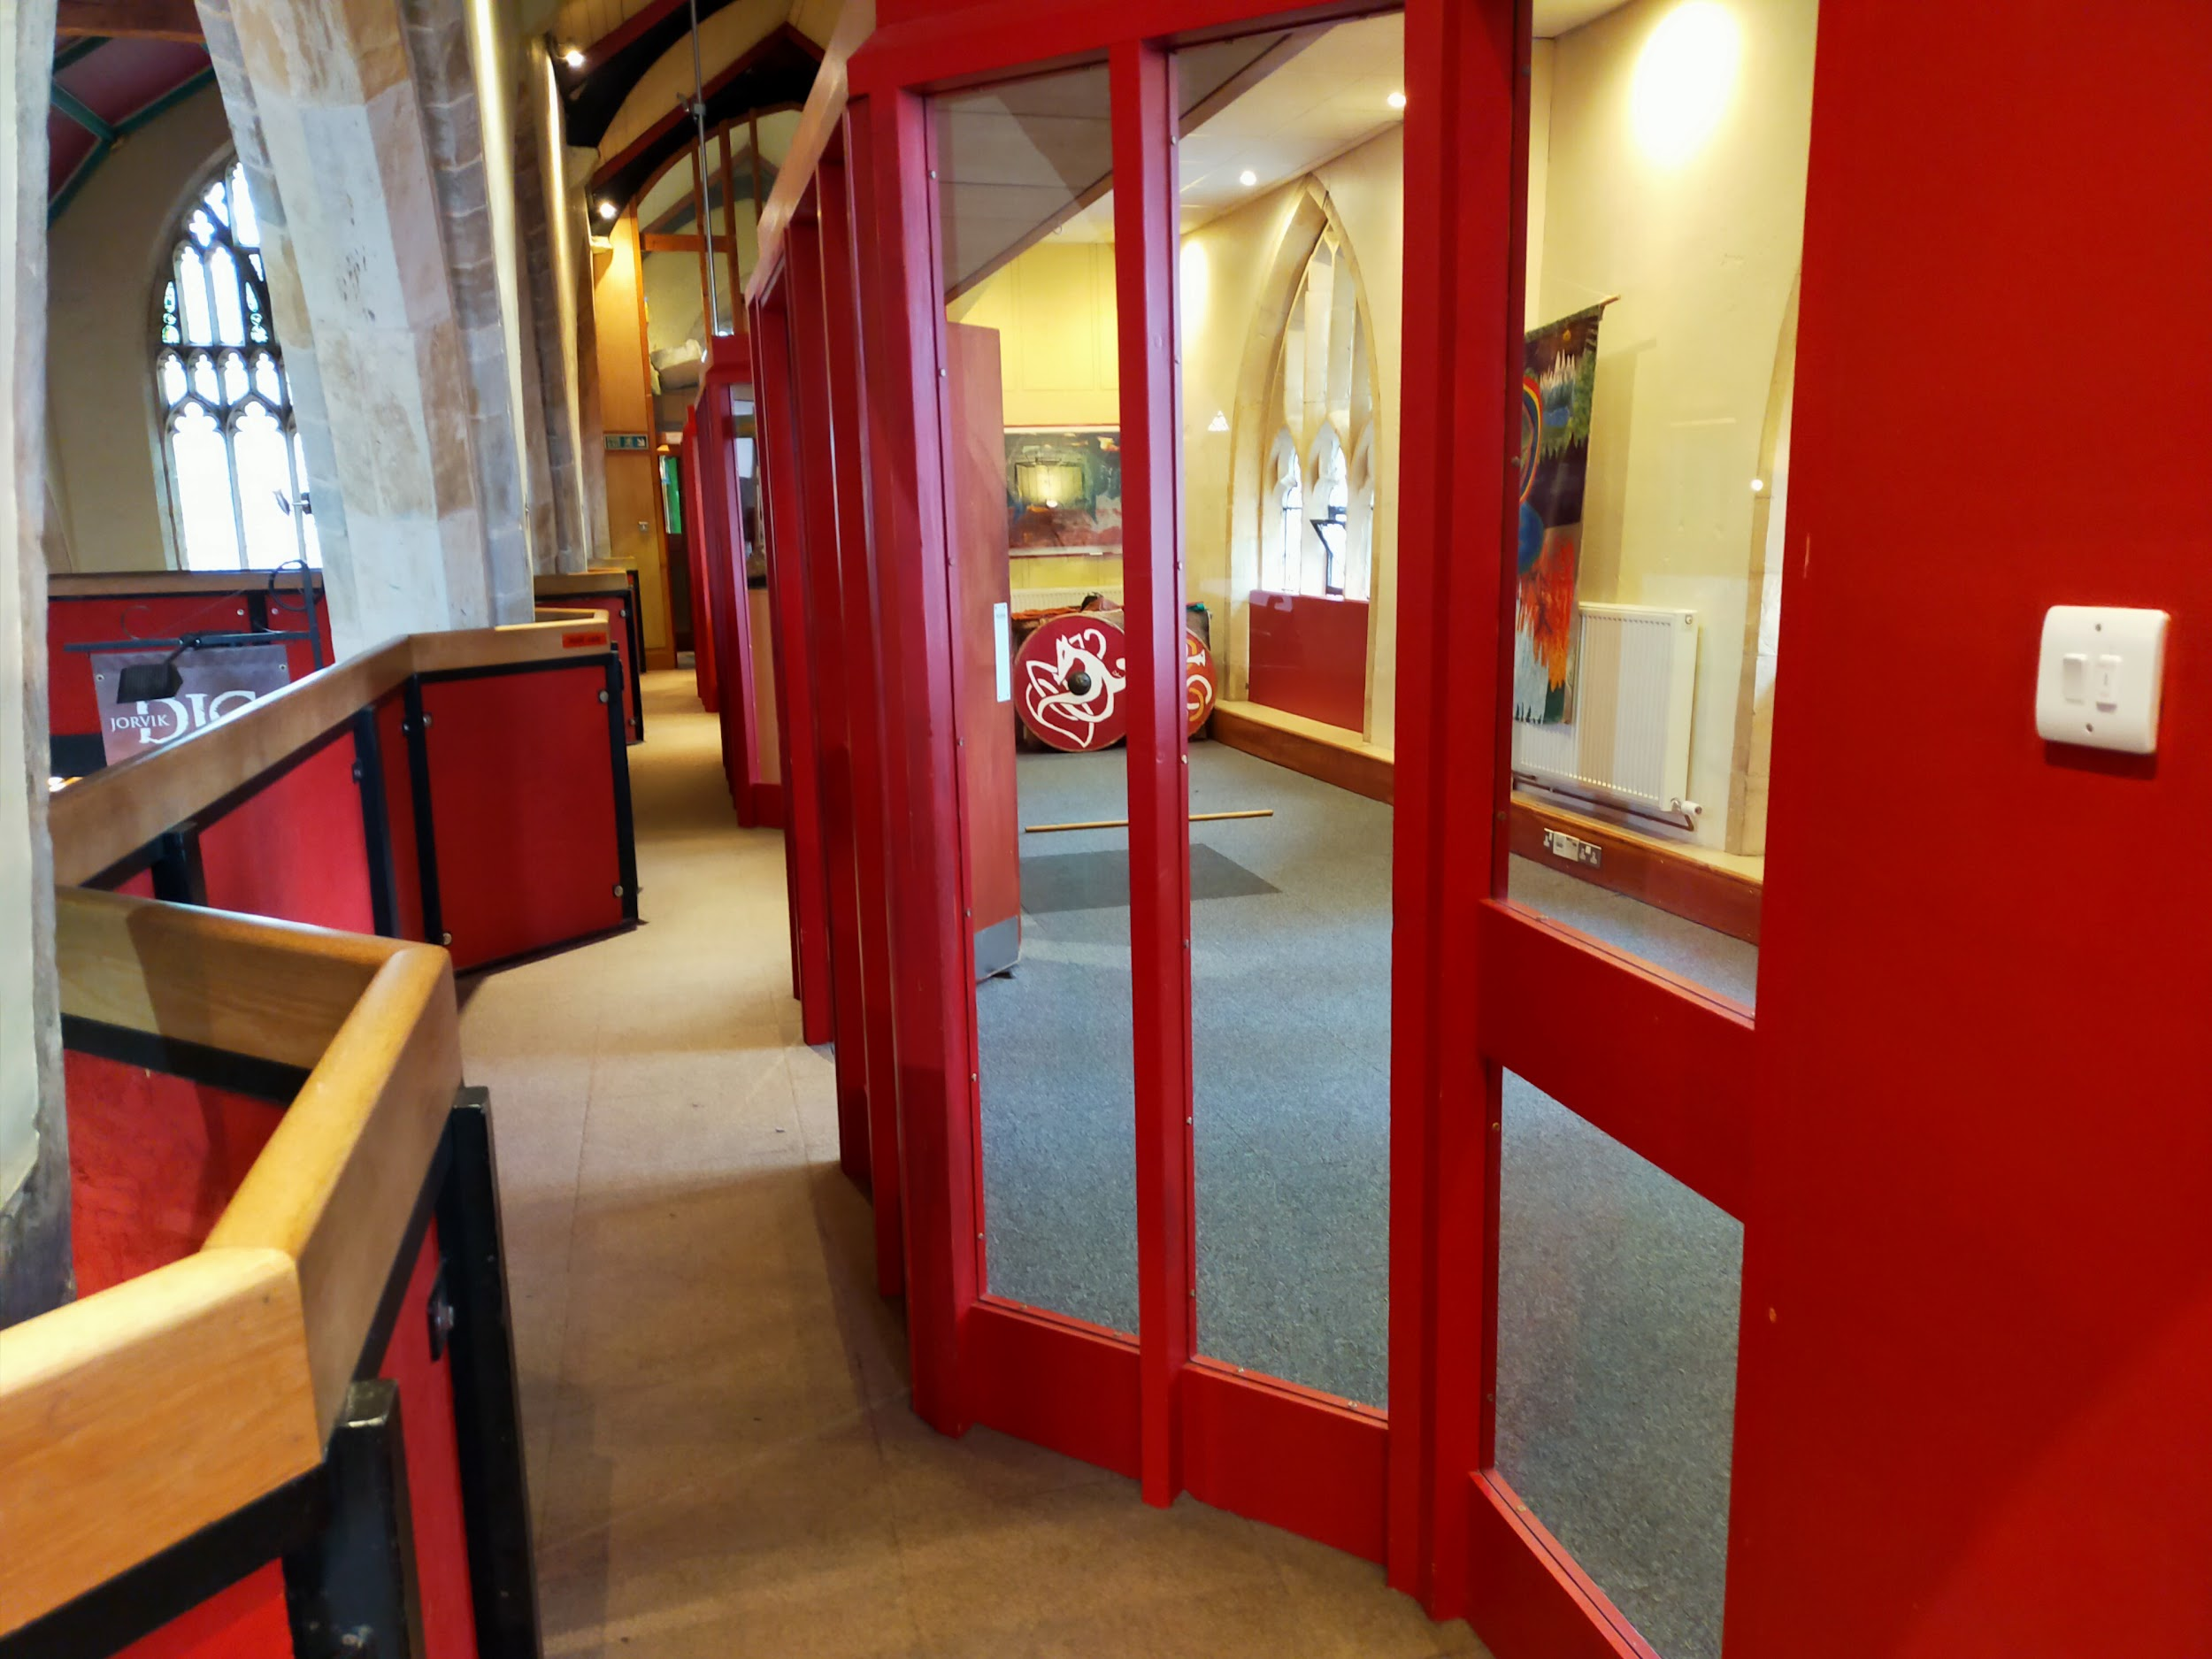
The room is carpeted and is the quietest area at DIG. We have several folding chairs in the room for you to use.

Lunch room
Our lunch room is a wide open mezzanine with tables and benches that’s set up for you to use. When a school is in, this is where they have their lunch, and it can be difficult to manoeuvre when all the tables and chairs are set up. This is also where birthday parties have their food and cake. The tables are 480mm high and the chairs are backless benches that are 430mm high.
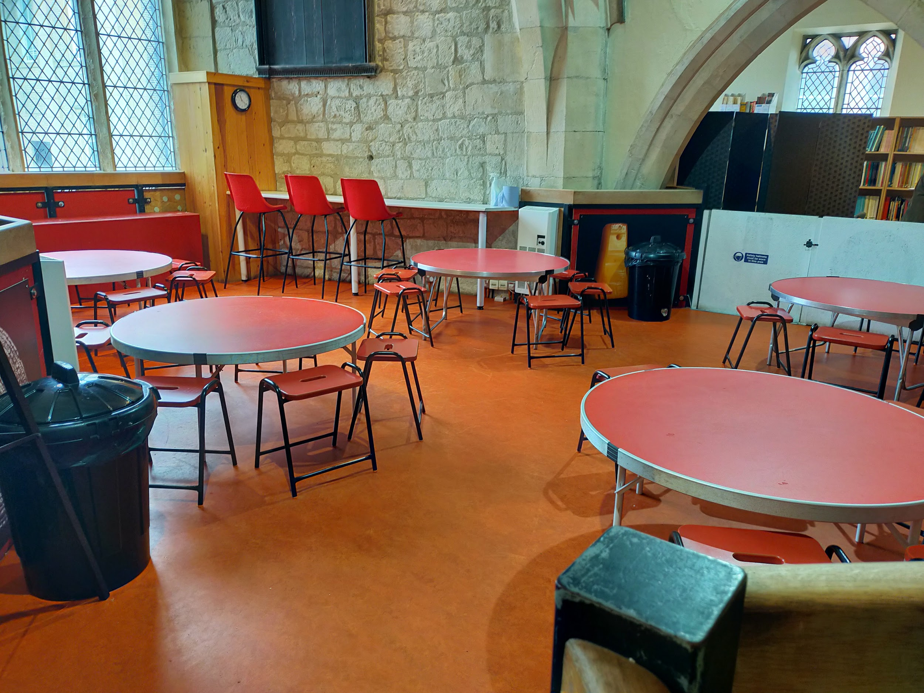
There is also a high table along the wall that can be used by visitors. The table is 890mm high and there are three chairs which are 800mm high.
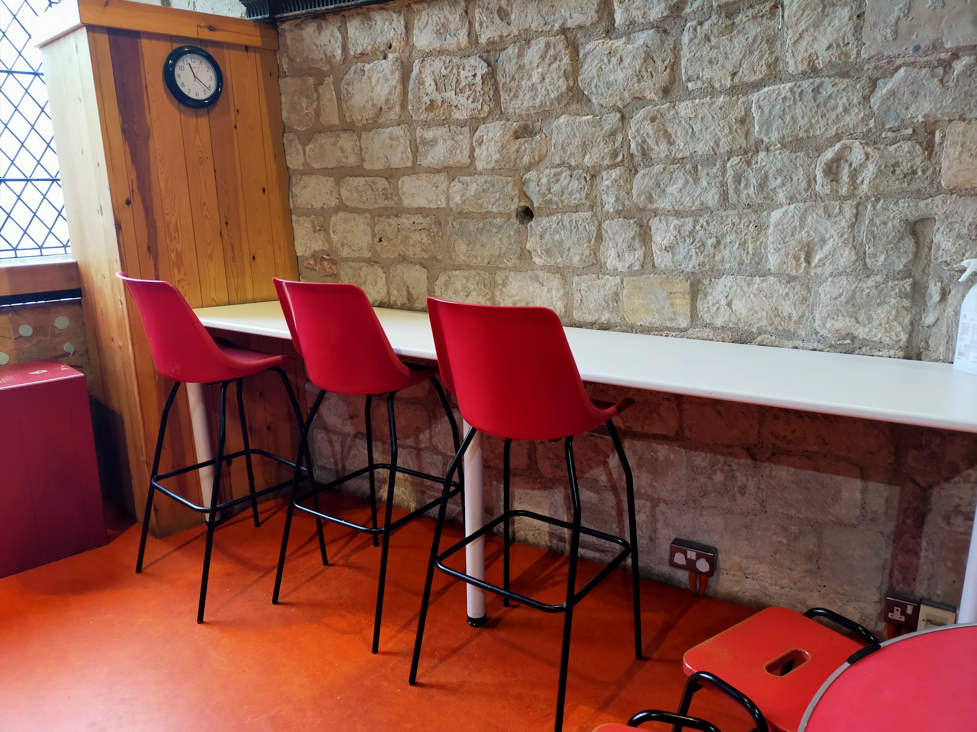
From the lift to here, there is level access with a very small lip as the carpet changes to linoleum.
This area can get very noisy when there are multiple schools in. If you would like a quieter place to eat, we have a garden area outside or talk to a staff member.

Outside DIG
We are very lucky to have a large garden area so close to the city centre. It’s normally a fairly quiet area, unless there is construction along the street. The entire area is mostly under tree cover - although we do have a horse chestnut tree which likes to toss conkers down in the autumn, so do be careful!
Please note that we don’t have any parking on site, although there is a taxi rank right at the front entrance to the building. You can also be dropped off and picked up there.

Picnic Area
We have four picnic tables in our garden that you are welcome to use. Each of these picnic tables are moveable and can be rearranged as needed. You are welcome to bring your own food to the picnic area.
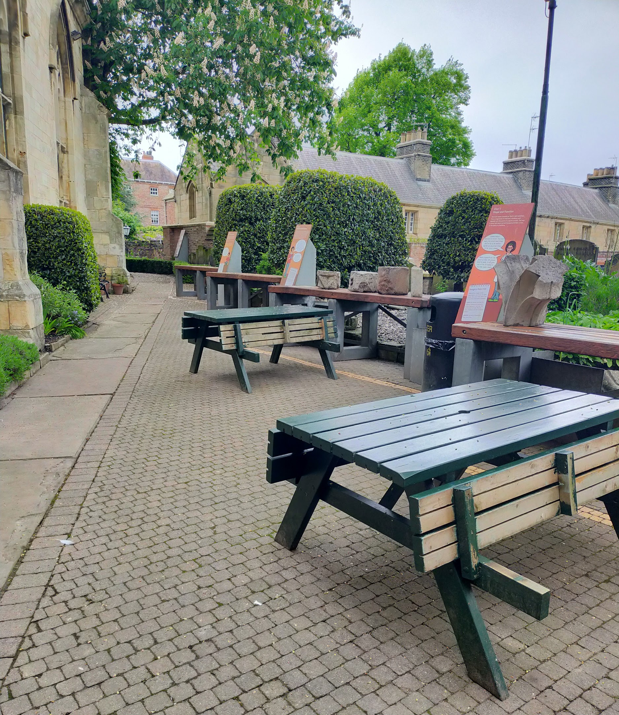
It is accessed via the rear exit of DIG through a door which swings outward and is 900mm wide. This door is wooden and can be quite heavy - please let us know if you’d like a hand.
The paving in the picnic area is a combination of brick, re-used gravestones, and loose gravel.
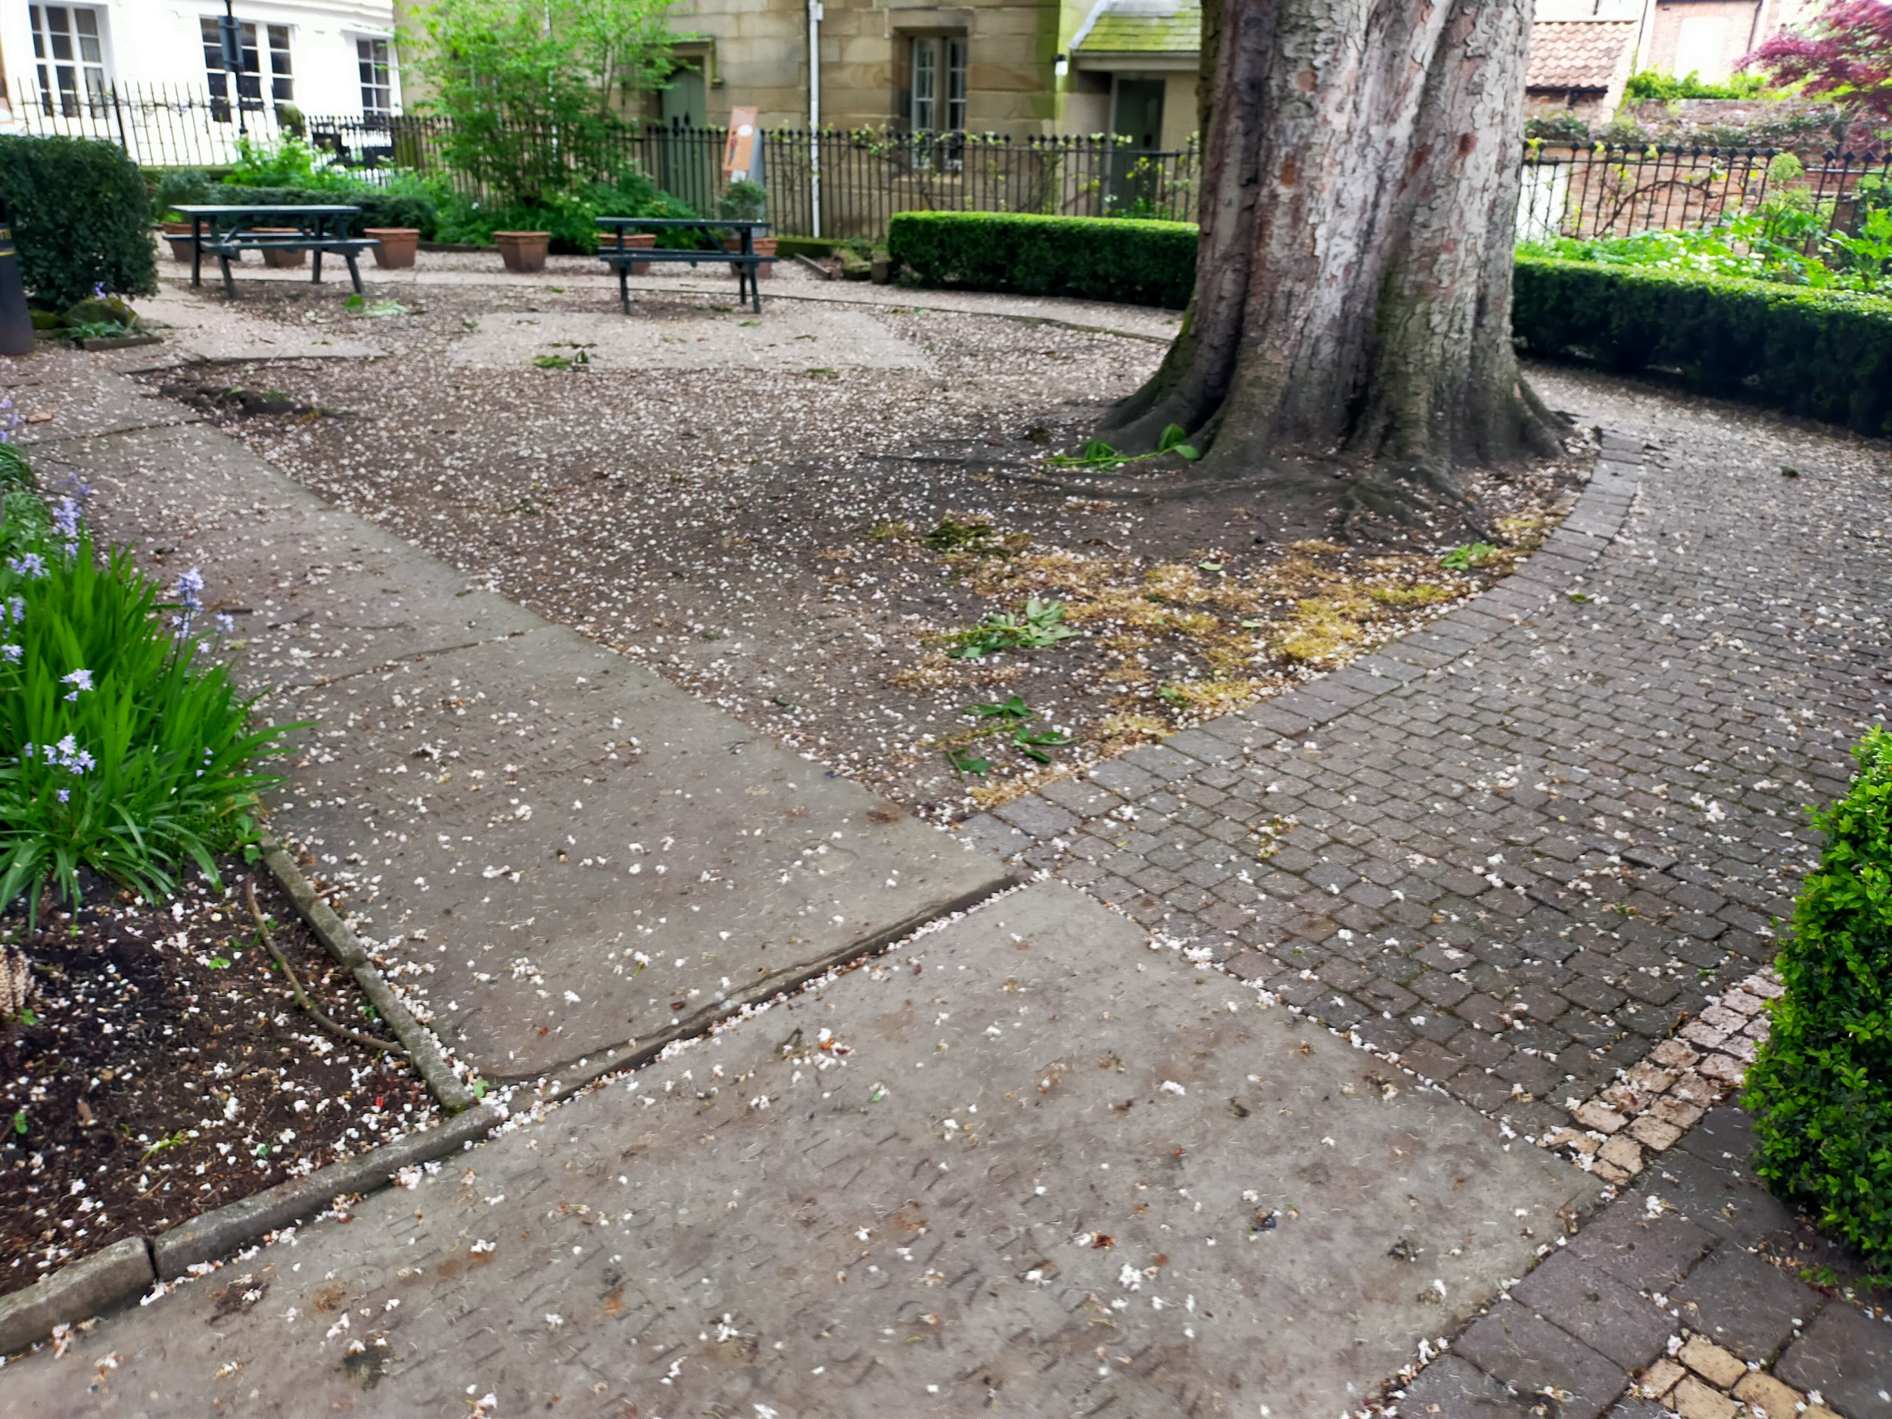
There is a level path from the door through the garden to the gated exit, which opens inwards and is 1400mm wide. This gate is also a fire exit and is kept unlocked as long as we are open.
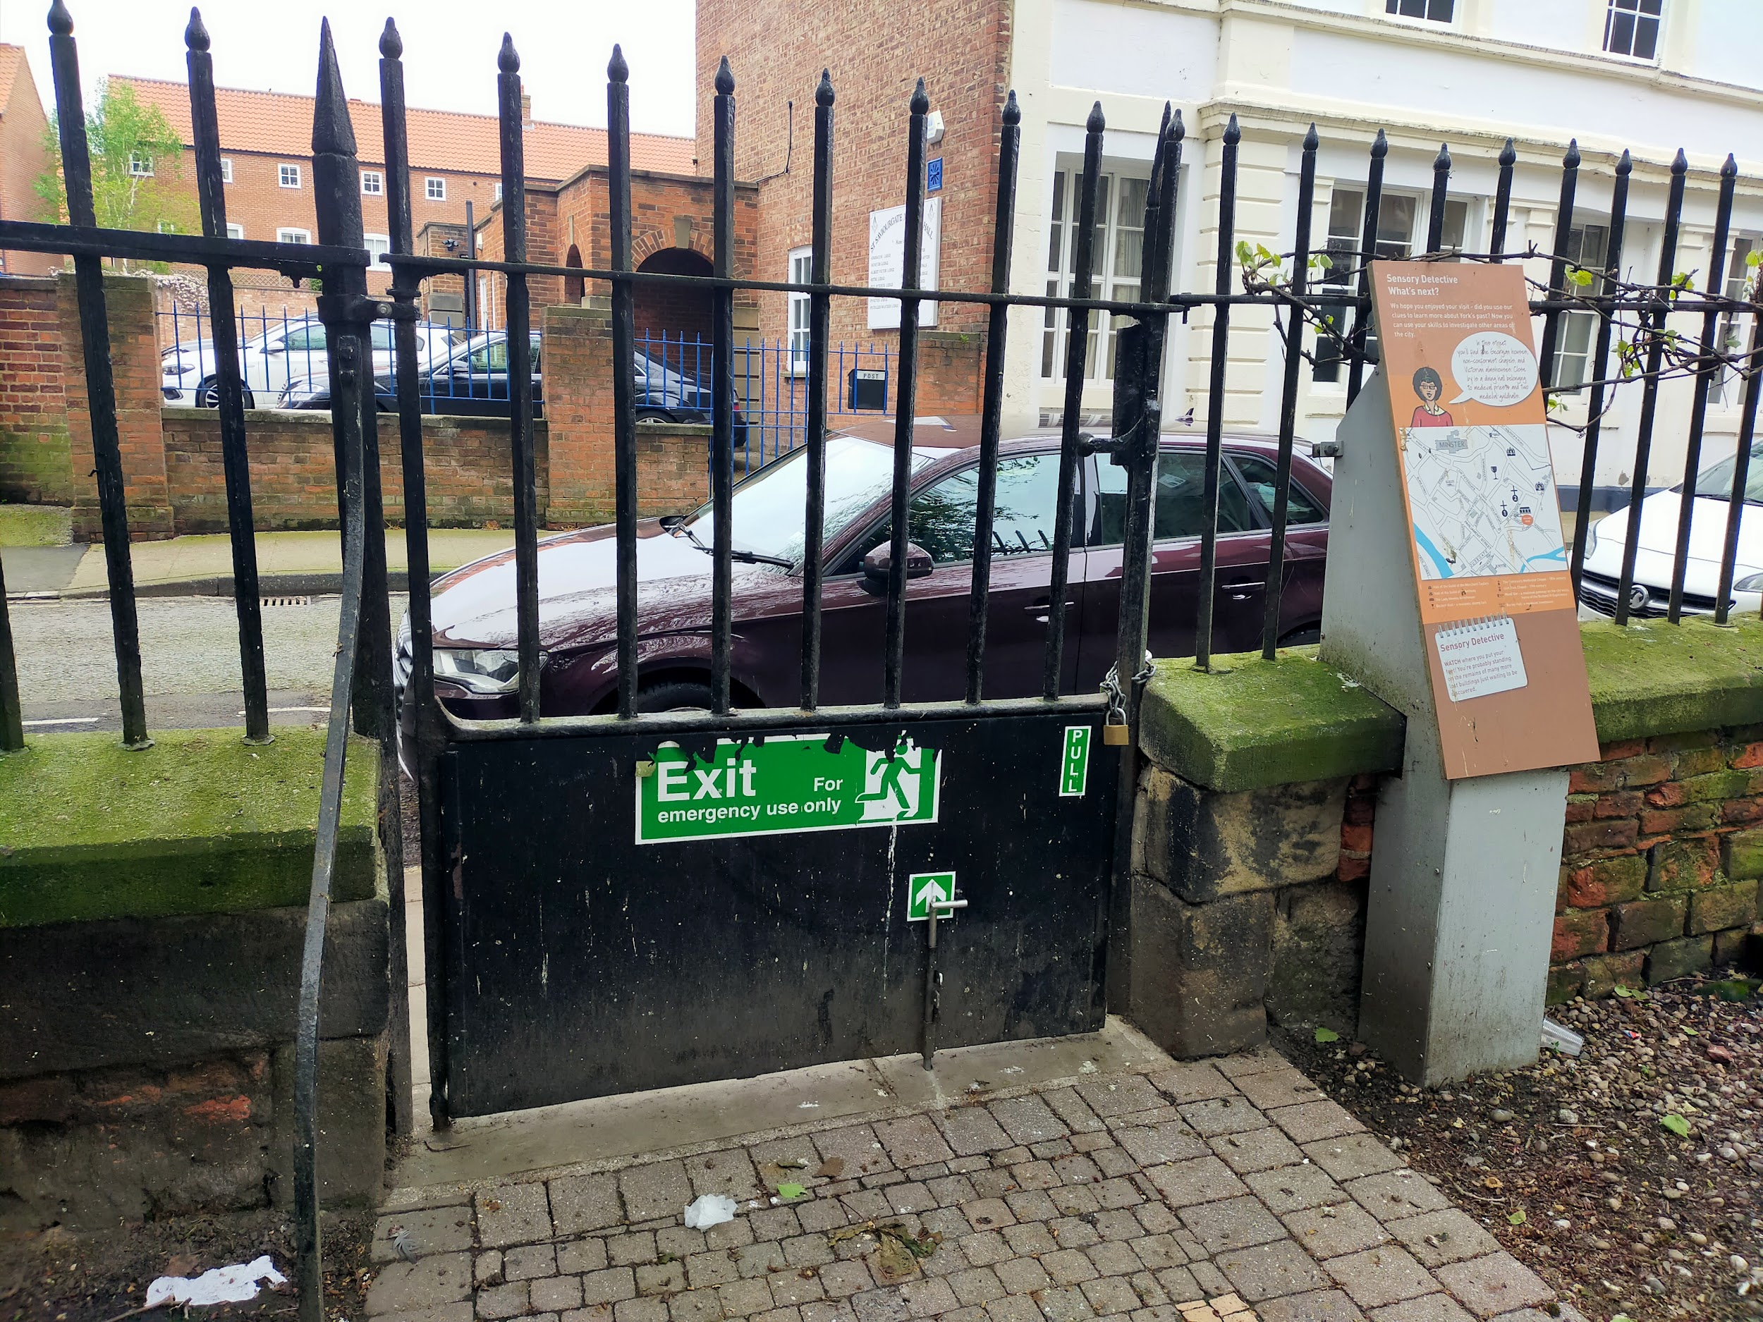
Please note that the re-used gravestones can be very slippy when it is wet outside. These gravestones came from the garden area, as it was formerly a graveyard when the building was still an active church. There are no human burials within the area anymore - they were removed when the building was converted and reburied elsewhere.

Sensory Garden
Throughout our picnic area is our sensory garden. The sensory garden has been designed specifically as a sensory experience. With a wide variety of colours, smells, and textures, as well as archaeological information, it is a fun and informative experience. There are plants that were used as medicine in the past, some examples of Medieval stonework that can be touched, and an array of wildlife that comes to the garden as well.
Allergy note: as we have flowering plants, we often have bees and sometimes wasps in the garden. Please use caution if you are allergic to bees.

Customer care support
We work to welcome all disabled people to our sites through a variety of training, feedback, and sector-led research. We are always keen to improve our offer, so if you have any suggestions, please email us at access@yorkat.co.uk
Breastfeeding is welcome at all our sites, and there is seating throughout for you to use.

Accessibility equipment
We provide the following accessibility equipment free of charge to visitors:
- A folding wheelchair
- Folding chairs
- Ear defenders
- Large print guides
- Visual stories
- Sensory packs containing various tactile and visual items, including fidget/fiddle objects
We have an area to charge mobility scooters and battery powered wheelchairs.
We also operate a traffic light sticker system at all our attractions:
- Red sticker = please do not approach me
- Yellow sticker = please answer my questions but let me approach first
- Green sticker = please approach and speak to me
You can pick up the sticker colour of your choice at the front desk.

Service Animals
Service animals are very welcome. We have had some service animals in the past that have been confused by the soil in our dig sites - subject to how busy we are, we can let you visit the dig sites before joining a tour to let your service animal become accustomed to this.
We have a water bowl at the admissions desk for them to use.
Service animals may toilet in the garden area - please avoid near the picnic tables. There is a stony area near the gate that is preferred for animals to use.

Emergency evacuation procedures
DIG is located inside a Grade II* listed medieval church and has a very open floor plan. In case of an emergency, staff are trained to help everyone evacuate quickly and efficiently, and have been given specific training to help disabled visitors evacuate.

Staff Training & Awards
All staff receive the following training:
- Welcome Host Plus
- Disability Awareness
- Blue Assist
- Autism Awareness
- Dementia Friends
- Sight Loss Awareness Training (from MySight York)
- Sighted Guide training (from MySight York)
- Hidden Disabilities Sunflower Lanyard scheme
Some staff have also received BSL training, and we are working to increase the number of staff with this training.
We also take part in the Visitor Attraction Quality Assurance Scheme (VAQAS) run by VisitEngland.
All DIG tours are fully guided by a staff member and therefore are naturally tailored to suit the needs of the group. Our tour guides are incredibly knowledgeable in accessibility and are working constantly on making DIG as inclusive and accessible as possible.
We have been recognised for our work in accessibility and won the following awards:
- Autism Friendly Award (National Autistic Society) - 2019, 2021
- Bronze for Accessible and Inclusive Tourism (White Rose Awards) - 2019
- Accessible and Inclusive Tourism (Visit York Awards) - 2020
- Silver for Accessible and Inclusive Tourism (White Rose Awards) - 2020
We have also been shortlisted for other awards:
- Accessible and Inclusive Tourism (Yorkshire Tourism Awards) - 2020, 2021, 2022
DIG is a designated Safe Space.

Sensory Information
DIG is a very hands-on experience with an emphasis on tactile learning.
Due to the nature of the building, the sensory environment of DIG can vary widely depending on how busy we are. We are in a converted medieval church with lots of open space and hard surfaces, so noise travels and echoes a lot. If we have multiple school groups in or it is during school holidays, the building can be very loud and overwhelming.
During school holidays, the classroom is available as a quiet space if you need it. We also have a small number of ear defenders. Our garden is always available for you to take a breather too.
Our quietest times are Sundays, especially during the morning, and most afternoons during the week after 3pm. You can always contact our Reservations team at groups@yorkat.co.uk or 01904 615505 to determine the best time for your visit.
All tickets are valid for 12 months, so you can also leave and return at another time if you need to at no additional cost.

Guide last updated: May 2023

